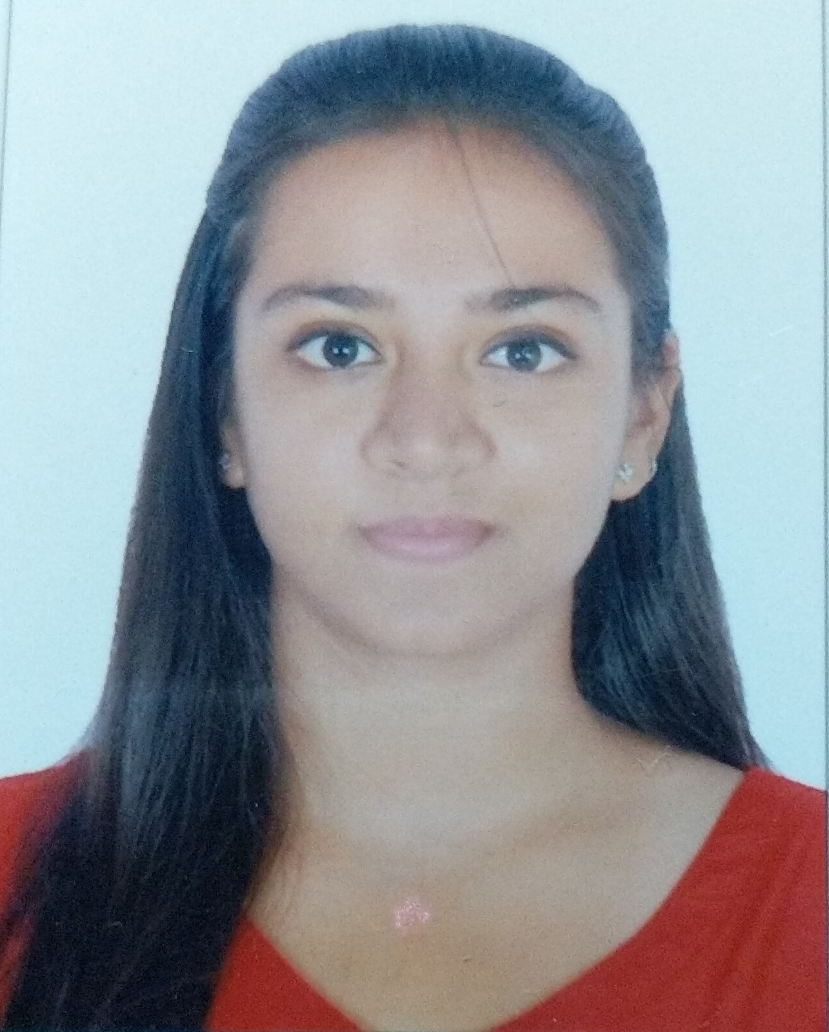
ANTRA PRIYADARSHANI

Female, Indian, 24 Years Mob: +917838001118, Mail:antra.ayusha@gmail.com
Language: English, Hindi http://linkedin.com/in/antra-priyadarshani-9792731b2

Career Summary

A Masters level student & working professional with around 10 months of experience as a Research Analyst (Medical Devices), trying to grow as a professional by working in a challenging atmosphere with an organization which provides me an opportunity to exhibit my creative best with utmost sincerity and dedicated smart work for the growth of the esteemed organization along with mine.

Academics
Degree | Institute | Year | CGPA
PGCP (Product Management) | IIM Indore | 2021-2022 | Pursuing
M Tech (Biotechnology) | Amity Institute of Biotechnology, Amity University, Noida, UP | 2021 | 7.63 | 1st Class

Internship History and In- House Projects
 | Organisation | Domain | Duration
1st Internship | National Brain Research Centre, Manesar, Gurgaon, Haryana (Deemed University under Ministry of Science & Technology, Government of India | Establishment and Characterization of co- culture of astrocytes and neurons. | June - July, 2019 | 42 Days
2nd Internship | Mankind Research Centre, Manesar, Gurgaon | Microbial analysis of pharmaceutical products | Feb - March, 2020 | 33 Days
3rd Internship | Mankind Research Centre, Manesar, Gurgaon | Microbial Analysis and Method Validation | August - Oct, 2020 | 65 Days
4th Internship | Data Bridge Market Research Pvt Ltd., Gurgaon | Global Smart Medical Device Market – Forecasting 2021 - 2028 | Oct, 2020 – May, 2021 | 6 Month and 22 Days
In-house Project | From Amity Institute of Biotechnology | Project Title: Signal Transduction and diabetes  Project Title: Huntington’s Disease  Project Title: Depth First Search and Breadth first Search | May-July,2017  May,2018  September,2019

Employment History
Sr | Designation | Organisation | Domain | Duration
1 | Research Analyst-Level 2 | Data Bridge Market Research Pvt Ltd, Pune | Healthcare – Medical Devices | Oct., 2020 – Till Today | 10 Months

Data Bridge Market Research Pvt Ltd, Pune Current Location: Gurgaon Oct., 2020 – Till Today

Working as a research analyst (Market Estimation analyst) in the healthcare department (Medical Devices).
- Primary and Secondary Research, Market Estimation, Forecasting & Trend Analysis,
- Product Mapping, Company Profiling, Company Landscaping
- Covid-19 Impact analysis, SWOT analysis
- Working knowledge of MS Excel, MS word, MS Power Point

* Got promoted within 10 months of joining Data Bridge Market Research Pvt Ltd.

Achievements & Certifications

- Captain of the girls Kabaddi team of Amity Institute of Biotechnology.
- Won Gold Medal in Kabaddi thrice for Amity Institute of Biotechnology at Amity University, Noida
- PAPER for publication in Journal (Journal of Family Medicine and Primary Care): Middle class of India Fighting COVID-19 but giving in to mental health? Sent to the journal for Publication (yet to be published)
- CRISPR basic certification course [on-going]
- Drug Discovery and genome editing using CRISPR- certification course [on- going]

Skills

- Leadership, team work and team management skills
- Quick Learner, Adaptability, Ability to work under pressure, Courage to take on extra responsibility, Diligent.
- Market estimation, company profiling
Interest

- Free style dancing
- Passionate about sports: Tennis, Kabaddi, Basketball etc.
- Love to watch movies, and TV shows, listen to music.
- Driving & Travelling
References

- Dr. Shivani Chandra, Assistant Professor Amity University, Ph: 8447786680
- Mr. Pankaj Labh: At Mankind, Ph.: 9560866445
- Rahul Kumar Sharma, Research Scientist, Mankind Research Center, Ph: 9891010727

