SREEPRIYA S

**Email ID:** [**sreepriyas1995@gmail.com**](mailto:sreepriyas1995@gmail.com) **Contact Number:**

**+91 7760953088**

# Career Objective

Looking for a challenging role in a reputable organization to utilize my technical, database, and management skills for the growth of the organization as well as to enhance my knowledge about new and emerging trends in the sector.

# Professional Experience

**January’2019 – Present - Documentation Executive Quality Analyst, Developing & Skilling, Quess Corp Limited, Bangalore. (1 Year 10 months Experiences)**

1. Use computers for various applications, mainly on database management or word processing. Content alignment and formatting. Complete handle of excel(MIS)
2. Prompt in short cuts & Formulae and high analytic skills with logically sensibility on the dashboard of advance excel.
3. Emailing Reconciled MIS Report with data of visualized details. Generating reports on priority bases.
4. Completely organized on the central government projects PMKVY(Pradhan Mantri Kaushal Vikas Yojana) and DDUGKY(Deen Dayal Upadhyaya Grameen Kaushalya Yojana)
5. Working on the project NAPS (National Apprenticeship Promotion Scheme) under NSDC (National Skill Development Corporation), handling more than 25 establishments, coordinating with them on daily basis till their claims and reimbursement for that particular establishment.
6. Coordinating with training centers across the state and monitoring of operational work. Acting as a catalyst for collecting details for future conservation.
7. Handling multiple clients (B2B & B2C) with their reports.
8. Operating on session planning regarding to the content and their lesson plans according to the particular projects (ACLP’s). Recording, analyzing and distributing statistical information of the candidates and different establishments.
9. Taken up RPL (Recognition of prior learning) projects.
10. Handled Balmer Lawrie & Co. Ltd Apprenticeship Program 2019-2020.
11. Handling logistics of books through the NSDC portal to the training centers across states (Pan India).
12. Analyzing the Quality of documents and establishment documents.

# Major Skills

* Microsoft Office all functions (Mainly Excel spreadsheet most of the formulae)
* Advance knowledge of MS Excel
* Strong Technical skills in Data Processing and Mining Tools.
* Content Alignment and Formatting.
* Mail Mapping.
* Management information system with heavy data (MIS)
* Client Management

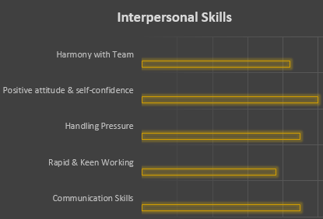

# Academic Qualification

**Bachelors of Engineering**

**Electronics and communication (2018)**

Atria Institute of Technology Visvesvaraya Technological University,

**Aggregate – 65.28%**

# Declaration

I do hereby declare that the above information is true to the best of my knowledge**.**

**Place: Sreepriya S**

**Date: (Signature)**