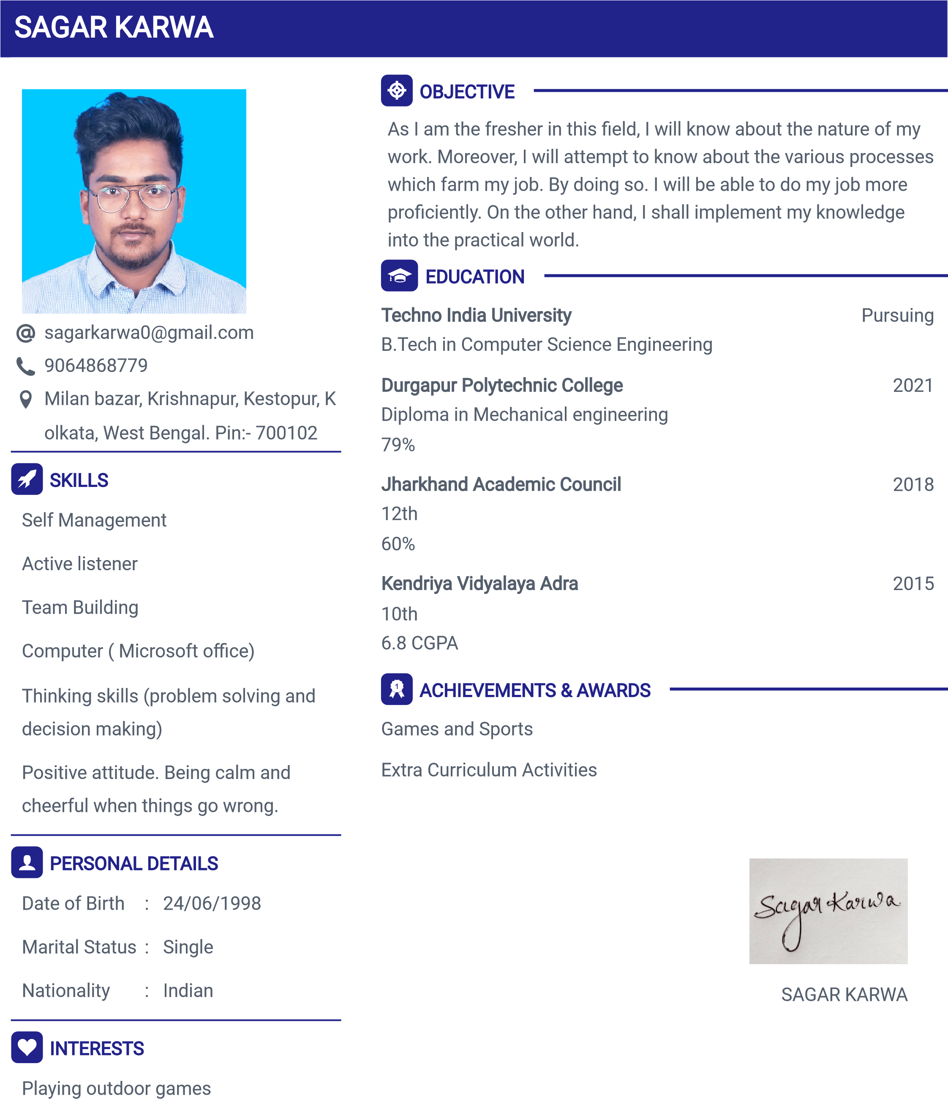
Surfing through internet

LANGUAGES
English
Hindi
Odiya
Bengali

