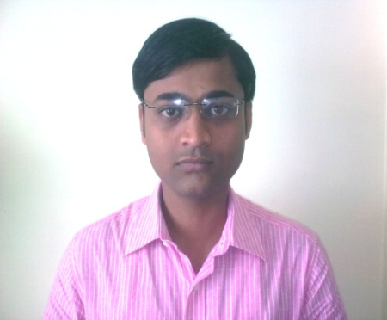
RESUME
PRABIR DAS
123-AJOY NAGAR, MIDDLE ROAD
P.O-SANTOSHPUR,
KOLKATA-700075, W.B.

Mob: +919163058447
E-mail Id: dasprabir600@gmail.com,
dasprabir54@yahoo.com

OBJECTIVE:
- Want to work in a challenging environment which provides me more experience and grow opportunities in the near future.

PROFESSIONAL QUALIFICATION
2011, M.B.A (FIN) from Sikkim Manipal University & CIDB from APEX Collage
ACCADEMY QUALIFICATION
- 2008, Bachelor of Commerce from Calcutta University.
- 2005, Higher Secondary from W.B.C.H.S.E.(W.B)
- 2003, Madhyamik from W.B.B.S.E.(W.B)
PROFESSIONAL EXPERIENCE:

3) M.M INFRA NIRMAN (P) LTD
Position worked as : Asst. Accountant (Taxation).
Duration: 7th April, 2013 to till date.
Place: GA-24, Rajdanga Main Road, Kolkata-700107,-
Key Responsibilities:
Maintaining Accounts in ERP TALLY 9, Documentation, Preparation of Monthly Bank
Reconciliation Statement, Follow up all banking transactions, Bill Checking, Online
Payment made to the Vendors.
Online Payment & Prepare Return of VAT, CST, P.TAX, TDS etc and also maintain of these taxation records & Documents.

2. BENGAL CONSTRUCTION & COMPANY
Position worked as : Ass. Accountant.
Duration: 1st February, 2012 to 31st March, 2013
Place: 1137, Saila Green, Purbalok, Kalikapur, Kolkata-700109
- SUPERINTENDENCE CO. OF INDIA(P) LTD.
Position worked as : Ass. Accountant.
Duration: 24th December, 2010 to 25th January, 2012
Place: New No.244(old No.138) 2ndFloor,Angappan Naicken Street,Chennai
600001,

Key Responsibilities:
Maintaining Accounts& documents, follow up all banking Transactions, Bill Checking,
Online Payment made to the vendors.
COMPUTER KNOWLEDGE:
Proficient in M.S Office, Tally (9), Internet, Online Taxation.

Current Salary - 10.000/- per month

PERSONAL DETAILS:
FATHER’S | PARIMAL DAS
DATE OF BIRTH | 20TH JULY, 1987
PERMANENT ADDRESS | 123-AJOY NAGAR, P.O-SANTOSHPUR, KOLKATA-700075
LANGUAGES KNOWN | ENGLISH,HINDI, BENGALI
MARITIAL STATUS | MARRIED
PASSPORT NO. | J8180858

Date:
Place: Kolkata (PRABIR DAS)

