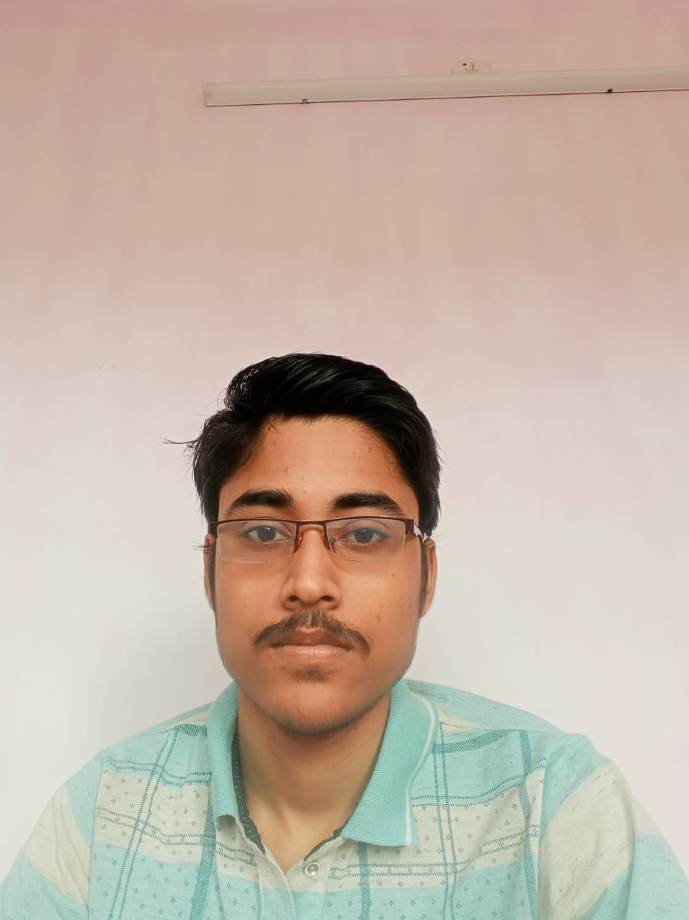 |  | Archi Roy
Profile  I am a hard working and punctual person. I have good ability to learn things quickly.  Contact  PHONE:  7980411850  EMAIL:  Royarchi600@gmail.com  Hobbies  Travelling, Reading Books and playing cricket |  | EDUCATION  [School Name] – Gangapuri Siksha Sadan  10-12-2005 – 12-12-2018  College Name – Prafulla Chandra College  10-05-2018 – 09-07-2021  Accountancy Honours  SKILLS  Basic Computer Knowledge  Have basic knoiwledge about MS Office, Ms Excel, Ms Word

