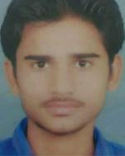
Ishu Pandey

pandeyishu99@gmail.com

8707003007

NA

NA

CAREER OBJECTIVE

Secure a responsible career opportunity to fully utilize my training and skills, while making a significant contribution to the success of the company.

PERSONAL DETAILS

Address

Aminabad Pratap market Lucknow

Date of birth

25/09/1998

Gender

Male

City

Lucknow

State

Uttar pradesh

Pin Code

227309

Nationality

India

Marital Status

Unmarried

Religion

Hindu

Languages known

English, Hindi

Hobbies

Drawing, sketching and painting , Organising events in the community

WORK EXPERIENCE

Dishtv

Dishtv

Jan 2017 - Jan 2018

Admin

Mahendra Skills Training And Development Pvt Limited

Jan 2018 - Present

Handle branch official work

EDUCATION DETAILS

Degree/Course | Institution | University/Board | CGPA/Percenta | Year of Passing
 |  |  | ge
Graduate | BSNV PG | Lucknow | 58% | 2017
 | College | University
 | Lucknow
10 | Rastra Bharti | Up Board | 80% | 2012
 | Public Inter
 | College
12 | Rastra Bharti | Up Board | 80% | 2014
 | Public Inter
 | College

SKILLS

Communication

Computer skill

Leadership

ACHIEVEMENTS

Developed or

implemented new

procedures or

systems.

DECLARATION

solemnly declare that all the information furnished in this document is free of errors to the best of my knowledge.
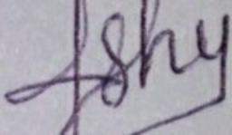

Date: 24/11/2020

Place: AMINABAD PRATAP MARKET LUCKNOW

Ishu Pandey

Powered by TCPDF (www.tcpdf.org)

