RESUME
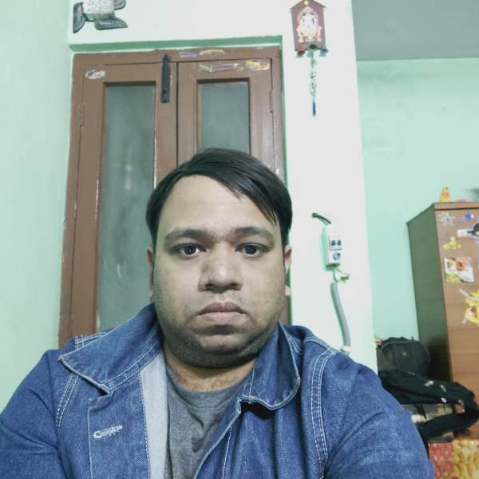
Name:Ravi Kumar Sharma
Address:103-b old anarkali
near sankat mochan balaji
mandir tikona park krishna
nagar delhi-110051
Email:-ravi6919@gmail.com
Mob:-9910155362

OBJECTIVE

Seeking a position of programmer/Developer in the field of IT and Communication where fresh talent will add the value to operations and utilize my skills and abilities.

TECHNICAL SUMMARY

Area of expertise : Android, Mysql, PHP, Java, C/C++.

ACADEMIC QUALIFICATION

- B.tech from AMIE/IEI in 2016/oct with 7.4 CPGA.
- 3 year Diploma specialization with ECE from Marathwada Institute of technology affiliated by Board of technical education in june 2007 with 69% marks .
- 10th Class from Ludlow castle no-2 approved by CBSE in june 2003 with 65% marks.

SKILLS PROFILE

- Programming Language: Android, Mysql, PHP, Java, C/C++.
- Basic Knowledge of MS office (MS Word, MS Excel, MS Powerpoint Notepad++ ) .

The Details of various project in chronological order:
1.Project Title : Expiry Reminder
Organization: Innobuzz knowledge solution.
Duration: 4 months
Tools used: Android studio, Android SDK 7.1, API 25,SqliteDatabase.

Project Description :
This project involved in developing a android mobile application which would enable users to get automatic expiry date notification about any items for examples foods,goods,medicines,documents etc.
Responsibility: I involved in Sqlite Database for data storage for items images ,place of purchase, price of items , Date of purchase and Date of expiry etc.

2. Project Title: Mozo rooms
Organization: Kept Bug technolgy
Duration: 2 years
Tools used: Android studio,Android SDK 7.1, API 25, MysqlDatabase
Server, PHP , JSON for data parsing and retrieving etc.

Project Description :
This project involved in developing a android mobile application of hotels room booking which would enable users for booking mozorooms hotel very easily and at cheap price .
Responsibilty: I involved in Mysql Database for data storage for example booking date, check out date, rooms price, rooms image, subject, message, email, mobile number etc.

WORKING EXPERIENCE

1.Company name: Easy pvt. Care Limited
Location : Noida B-77 Sector-63
Job Title: Senior Customer care executive
Duration:5 years 3 months
Role: Attend calls online on a dialler, resolved customers queries with UK clients took details from clients and transfer the data to legal team and legal team directly contact with clients and deal their claim on the basis of legal terms and condition after acceptance of their claim legal team provide the compensation money for personal injury.

2. Company Name : Kept Bug Technology
Location:Noida, G-129
Job Title: Android application developer
Duration:2 years
Role : Build and developed android mobile application with
Android SDK, worked on a live project with a team members.

3. Company Name:- Choice Chemptech Private Limited.
Location: - B-30 Sec-63 Noida-201301
Job Title:- Engineer Trainer
Duration: - 1 Month and 4 Days
Role: Components Mounting on PCB, Soldering, Breaking Panels, MI,
Packaging, Product quality Testing and maintenance etc .

4.Company name:- MCM
Location:- Sector -64 A -58 Noida
Duration:- still working from 22nd Feb 2018
Role:- IQC (Incoming quality control ). Checking and find defect in input raw material ,vendor NG material and hand over to assembly line with good materials.

5.Current Company:- Xiaolin electronic private limited.
Job profile:- IPQC
Location:- Noida sector 63 J-45..
DOJ:- 04 /05/2019
Role:- IQC (Incoming quality control ). Checking and find defect in input raw material ,vendor NG material and hand over to assembly line with good materials

BASIC DETAILS
DOB : 9TH MARCH 1988
Language Known: Hindi and English
Place : Delhi.

