Resume

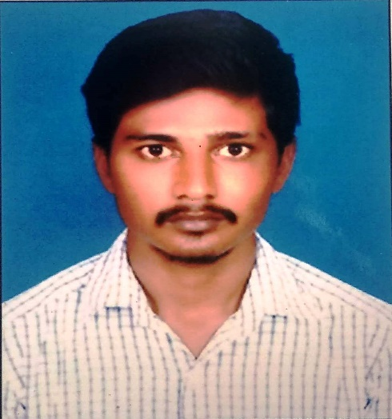  BALAJI.P  Email:massbalajicse96@gmail.com  Mobile:  +91-7092500872  Permanent Address:  S/o R. Periyasamy.  181/A Agraharam,  Vangal(PO)  Karur(Dt)  PIN-639001.  Competencies:  - Good team player, Fast Learner.  - Organized and well-structured at work.  - Committed to deadlines and schedules.  Hobbies  - Listening to music.  - Riding Bike.  Personal Profile  Date of Birth : 16.05.1996  Age : 26  Gender : Male  Nationality : Indian  Marital Status : Single  Father’s Name : R. Periyasamy  Mother’s Name : P. Rajeshwari  Languages Known:  - English (speak write).  - Tamil (speak write). | OBJECTIVE  Seeking a challenging opportunity in your dynamic  Organization to prove my mettle and there by grow with the company.  ACADEMIC PROFILE  TECHINICAL QUALIFICATION  2016 Diploma Computer Engineering,  Percentage Secured up to 6thsemester: 83%  HIGH SCHOOL  2010 ST. Mary’s Matriculation School,  Vangal  Percentage Secured : 69 %  SKILL SET  - MS-Office  - PHOTOSHOP  - SOFTWARE SKILL  - HARDWARE SKILL  - CCTV Camera SKILL  - TALLY PRIME SKILL  AREA OF INTEREST  - Java  - Dot.Net  - C++  - Hardware and Networking  WORK EXPERIANCE  - Employed as Hardware and Network Admin with Atlas Export Enterprises (Textile manufacturing and Exports) from June 2016 to March 2022.  CO-CURRICULAR ACTIVITES  - Mini Project in REAL ESTATE MANAGEMENT SYSTEM  .  EXTRACURRICULAR ACTIVITES  - Good leadership in my schooling junior red cross society  DECLARATION  I swear that the above mentioned information’s are true to the best of my knowledge.  DATE: Signature  PLACE: Karur [P.BALAJI]

