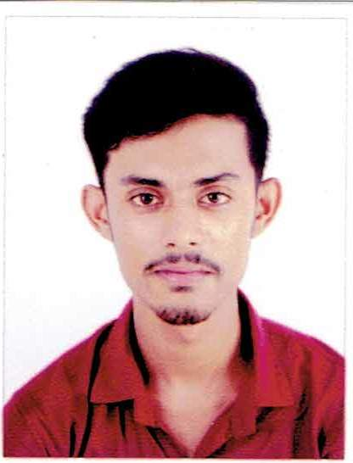

**CURRICULUM VITAE**

**JEET DEY**

**Ranjanpally, Chakdaha, Nadia**

**WEST BENGAL**

**PIN: 741222**

**Mobile no: +919563017854**

**Email: deyjeet40@gmail.com**

**Objective:**

To get aligned with a reputed organization and utilize my skills and ability through hard work while being innovative and flexible.

**EDUCATIONAL PROFILE:**

|  |  |  |  |  |  |  |  |  |  |  |  |  |  |  |  |  |
| --- | --- | --- | --- | --- | --- | --- | --- | --- | --- | --- | --- | --- | --- | --- | --- | --- |
| |  |  |  |  | | --- | --- | --- | --- | | **YEAR** | **EXAM** | **BOARD/UNIVERSITY** | **PERCENTAGE** | | 2009 | 10th Exam | WBBSE | 77% | | 2011 | H.S | WBCHSE | 62.8% | | 2016 | B. TECH | W.B.U.T | DGPA 7.01 | |

**Extra Curriculum Activities:**

Vocational training in Civil Engineering.

**Other Activities & Hobbies:**

* Listening Music, Traveling, Playing Cricket.

**Personnel Profile:**

**Father’s name : Mr. Prasanta Dey**

**Mother's Name : Mrs. Papia Dey**

**Gender : Male**

**Date of birth : 04-04-1994**

**Nationality : Indian**

**Marital Status : Unmarried**

**Languages Known : English, Hindi and Bengali**

**DECLARATION:**

**I hereby declare that all the above furnished details are true to the best of my knowledge**

**Place: Chakdaha**

**Date: (JEET DEY)**