RESUME

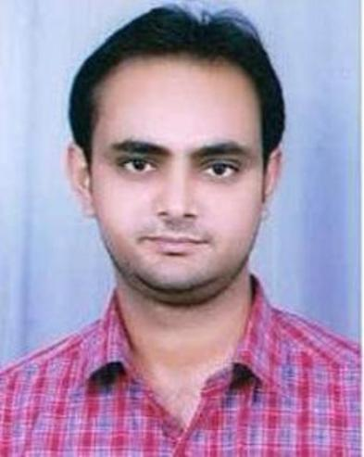

POSITION APPLIED FOR THE POST
- Procurement Manager

CONTACT INFORMATION
Name NITIN KUMAR
E-mail id nitin.kumar166@gmail.com Contact No. 09837013270
Aadhar No. 3036 3718 8120
Permanent Address Yakut Pur Mavi Niwari Road Modinagar (201204) Distt. Ghaziabad (U.P.)

CAREER OBJECTIVE
To secure a professional position that utilizes my engineering education in the technical field by using teamwork, computer skills and creative thinking in teaching and that will benefits the students to grow their career.

TOTAL EXPERIENCE (8 YEARS)
- Presently worked as a Lab Instructor in C.S.E. Deptt. At “SRM Institute of Science and Technology, Modinagar” from 12 Sept. 2018 to till date.
- I had worked as an “Assistant Professor” in C.S.E. Deptt. At “D. J. College of Engineering and Technology, Modinagar” from 20 July 2015 to 24 August 2018 (3 Years).
- I had worked as a “Lecturer” in C.S.E. Deptt. At “R. D. Engineering College, Ghaziabad” from 09 January 2012 to 15 July 2015 (3 Years).
- I had worked as a “Lecturer” in C.S.E. Deptt. At “D. J. College of Engineering and Technology, Modinagar” from 10 August 2010 to 18 August 2011 (1 Year).

ACADEMIC QUALIFICATIONS
- M.Tech (Computer Science and Engineering) from R.D. Engineering College Ghaziabad affiliated to Dr. A.P.J. Abdul Kalam Technical University (AKTU) Lucknow.

Degree | Year Of Passing | Final (%) | Division
M.Tech. | 2016 | 73 | First

- B.Tech (Computer Science and Engineering) from D.J. College of Engineering & Technology Modinagar, affiliated to Dr. A.P.J. Abdul Kalam Technical University (AKTU) Lucknow.

Degree | Year Of Passing | Final (%) | Division
B.Tech. | 2010 | 64 | First

- 12th from U.P. Board Allahabad in the year 2006 with Second Division.
- 10th from U.P. Board Allahabad in the year 2003 with Second Division.

TECHNICAL SKILL SET
- Programming Language: C
- Operating Systems: Windows XP,8 &10
- Software Applications: MS Office (Word 2007, Excel 2007)

KEY RESPONSIBILITIES
- Maintaining the records of lab equipments and discipline in the lab.
- Demonstrating proper use of computer systems to students.
- Adept in resolving computer system software issues and related to programming issues.
- Maintained all students lab entry register with computer system wise student’s record.
- Maintained the stock management status of computer lab.

WORKSHOPS
- Attended a workshop on “Advanced Wireless Sensor Network” conduct by Information Technology department from 9th to 13th July 2018 at KIET Ghaziabad.
- Attended a workshop on “Android Developer Fundamentals Faculty Training” conduct by Information Technology department from 27th to 31st March 2017 at KIET Ghaziabad.
- Attended a workshop on “Network Security and Firewalls through ICT”, conduct by Computer Science department from 18th to 22th Nov. 2013 at National Institute of Technical Teachers Training and Research (NITTTR) Chandigarh.
- Attended a workshop on “Computer Networking through ICT”, conduct by Electronics and Communication department from 04th to 08th Aug. 2014 at R. D. Engineering College Ghaziabad.
- Attended a workshop on “Securing Network through Firewalls, VPN & IPS through ICT”, conduct by Computer Science department from 08th to 12th Sept. 2014 at National Institute of Technical Teachers Training and Research (NITTTR) Chandigarh.
- Attended a workshop on “MATLAB and its Applications through ICT”, conduct by Electrical Engineering department from 15th to 19th Sept. 2014 at R. D. Engineering College Ghaziabad.

PERSONAL DETAILS
Father’s Name Mr. Sukhpal Singh
Date of birth 05 June 1988
Gender Male
Nationality Indian
Marital Status Married
Religion Hindu
Category OBC

DECLARATION
- I hereby declare that the information furnished above is true and complete to the best of my knowledge and belief.
- I have read and understood the above declaration before signing this.

Date: …………………

Place: Modinagar (NITIN KUMAR)

