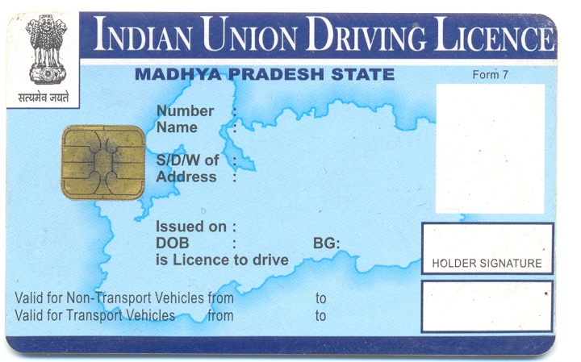

**MP09N-2010-1014474**

**CHANDRESH CHAUHAN**

**197 RAUNAKDIP APPT FLAT NO 201 INDORE**

**18/10/2030**

**18/10/2010**

**18-10-2010**

**06-02-1976**

**DINESH CHAUHAN**

**LMV**

# Issuing Authority INDORE RTO

**MC WITH GEAR**

**Authentication**

**See reverse for**