Adarsh E 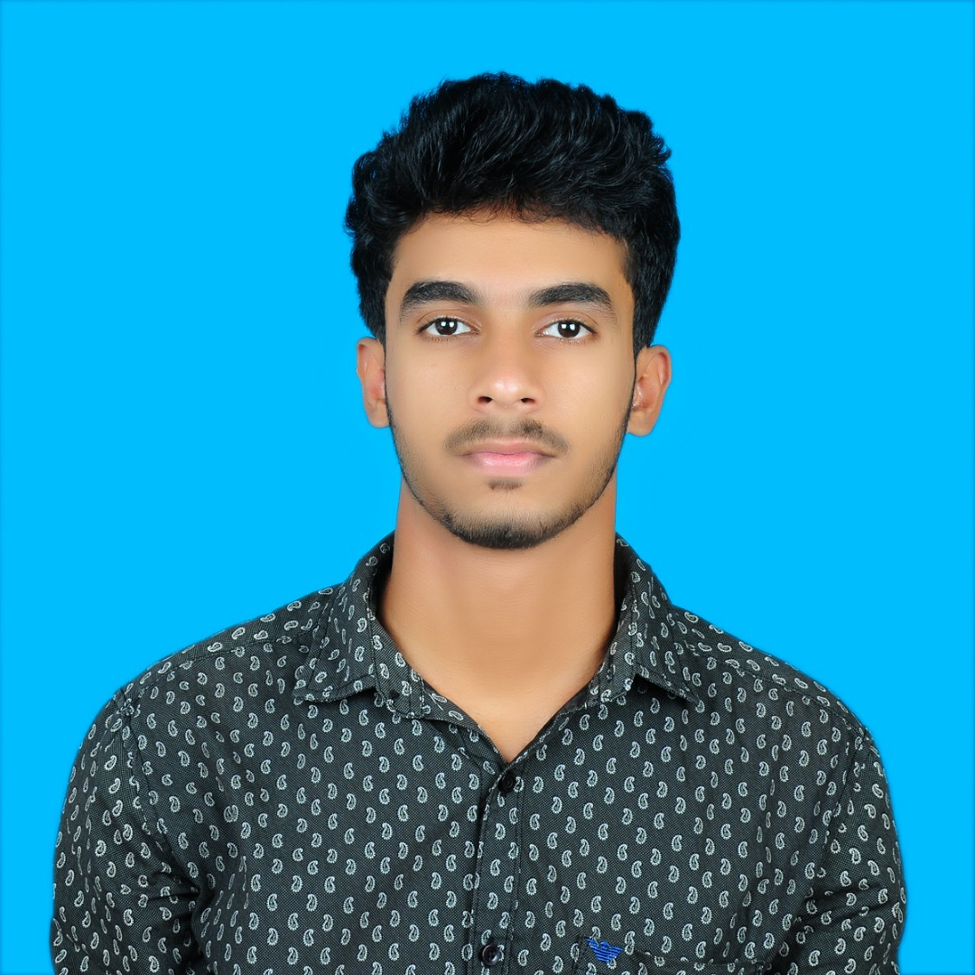V

TK House, Ayithara, Ayithara Mambaram (PO), Kannur-Kerala Pin:670643 | Ph.: +91 828 152 5451

Email: adarshev@gmail.com

DOB : 04-01-1996

Passport No.: M1116819

# OBJECTIVE

To succeed in an environment of growth and excellence and earn a job which provides me job satisfaction and self-development and help me to achieve personal as well as organizational goals.

# EDUCATION

## bachelor of engineering |2018| Nehru institute of engineering and technology

* Major: Mechatronics Engineering
* Main Project: Underwater Surveillance Robot
* Mini Project: Speech recognizing wheelchair for different terrain
* CGPA: 6.6

## higher secondary education | 2014 | RajEev Gandhi Memorial HSS

* Major: Computer Science (Mathematics, Physics, Chemistry, Computer Science)
* Score: 86%

**HIGH SCHOOL EDUCATION | 2012 | AMRITA VIDYALAYAM**

* Score: 92%

# WORK EXPERIENCE

# Calibration Engineer in Vaidyanatheswara Instruments Pvt.Ltd. June 2018 to June 2019

# Perform calibration and validation of all Electronics, Thermal, Mechanical,Mass and Volumetric Instruments.

# Conducted test and inspection of incoming devices to determine the quality of performance prior to acceptance.

* Accurately collected, complied, measured, recorded and summarized data during calibration processes, identified out of tolerance conditions and performed corrective actions via adjustments or component replacement.
* Administrative duties such as documentation, calibration report making and updation according to ISO and NABL standards.

# CERTIFICATIONS

* Industrial training in KSRTC regional workshop, Mavelikkara in June-2017
* Workshop on Autobots at National Institute of Technology, Trichy in February-2017
* Paper presentation in *3rd International Conference on Emerging trends in engineering and technology (Design and fabrication of milk Embedded System for Diary Farmers*) at Nehru Institute of Engineering and Technology done on 21st April-2016
* Certificate of completion of C Programming Language conducted by Six Phrases at Nehru Institute of Engineering and Technology

# PROFESSIONAL SKILLS

* Proficient in Microsoft Office- Word, PowerPoint and Excel
* Calibration
* AutoCAD (Basics)
* C and C++ Programming Language(Basics)

# ADDITIONAL SKILLS

* Proficient with Internet Online Research and Social Media
* Strong Interpersonal and Leadership Skills
* Powerful Written and Oral Communication skills
* Excellent Time management Skills
* Attention to Detail
* Analytical Skills
* Team Working

# LANGUAGE PROFICIENCY

|  |  |  |  |
| --- | --- | --- | --- |
| **Language** | **Speak** | **Read** | **Write** |
| **English** | Proficient | Proficient | Proficient |
| **Malayalam** | Proficient/Native | Proficient/Native | Proficient/Native |
| **Hindi** | Intermediate | Proficient | Proficient |
| **Kannada** | Intermediate | Beginner | Beginner |
| **Tamil** | Advanced | Beginner | Beginner |

# DECLARATION

I hereby declared that the above mentioned details are best of my knowledge.