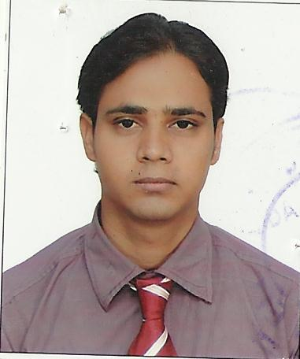

**Curriculum Vitae**

***REHAN MUSTFA***

**Mobile: +916386138286**

**E mail: rquadri29@gmail.com**

**Objective**

To work in an organization when I am able to continuously expand my knowledge and contribute effectively towards the growth of the organization.

**Academic Credential**

**.**Passed B.A from V.B.S Purvanchal University Jaunpur

. Passed Senior Secondary Examination (U.P.Board) in the year 2007

. Passed Secondary examination (U.P.Board) in the year 2005

**Experience**

. 12 Month exp in technical support eng from Secure System& Services

. 1 Years Exp Of Dubai at clerck Post in Jelfar Star Electro Mech Works L.L.C

.3 Years ExpIn Hospital Receptionist Now. Till Date

.6 Years Exp in Pharmacy Store As a Store Keeper مستودع امين الأدوية))

. 1 Years Exp Great India Palace In Lilliput Kids Wear Noida India

**IT Acumen**

. Operating Knowledge of Ms Office, and Internet

Knowing About All Medicine Have Pharmacy In India Exp With My Pharmacy

. 6 Month AutoCAD course from CAD ACADEMY NOIDA

. Drafting. Course 3 month

. Productivity tools course 3 month

. 3d mudding course 3 month

. 12 month Hardware& Networking from Shokeenda Pitampura New Delhi

. 6 month D.T.P (Desk Top Publication) from S.I.C Mau

**Language English:-**Read, Write, Speak Fluent

**Hindi:-**Read, Write, Speak Fluent

**Urdu:-**Read, Write, Speak Fluent

**Arabic:-**Read, Write, Speak Fluent

**Personal Details**

. Native Place: Ghosi Ma

. Date of Birth: 18-02-1991

. Father’s Name: Mr. Md Ahmad

. Marital Status: Single

. Nationality: Indian

. **Language Proficiency: English, Hindi, Urdu Arebic**

**Declaration**

I hereby declare that all the information given above is true to best of my knowledge and belief

**Date- ::**

**Place- (REHAN MUSTAFA)**