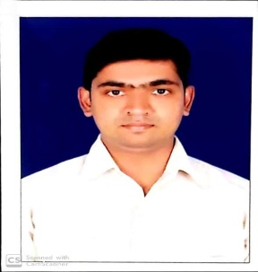S.Kiran kumar,

Mobile : 9121908773 E-mail address: kiran07.cfl@gmail.com

**Career Objective**

Intend to build a career with leading corporate which will provide me opportunity to explore myself fully and to prove my ability of being a key player in challenging & creative environment.

**Academic Profile**

**.**  Studying in B.com in distance education

* Completed Intermediate from Satya Institute of medical education and research College, Guntur with 69.03%, 2007.

* Completed SSC from Raghava Vidya Nilayam with 65.55%, 2004

**Skill Set**

* Good Communication and Presentation skills.
* Quick learning and Quest for more knowledge.
* Good team member and team leader qualities.
* Quick adaptability in any environment.

**Working expierince:**

I m working in joyalukkas jewellery showroom as period on 2010 to 2017 in India Andhra Pradesh

. Two years working in Malabar gold and diamonds jewellery show room as period on

Feb 2018 to Jan 2020 in Oman (GCC)

**Hobbies:**

* Playing and watching Cricket.
* Playing Chess.
* Listening to Music.

**Personal Profile**

Date of Birth : 11.01.1989.

Marital Status : married

Sex / Nationality / Religion : Male / Indian / Hindu.

Father’s Name : S.Venkataeswar Rao

Languages Known : English, Hindi, and Telugu,Malayalam

E-mail : kiran07.cfl@gmail.com

Address : H.no-6-86/2

Velagapudi vari street,

Near IREF church

, repalle, Guntur dust,A.P,India

Pin code-522625.

**Declaration**

I hereby declare that the information furnished above is true to the best of my knowledge. I am also confident of my ability to work in a team.

Date: 17/02/2020

Place-Vijayawada.

S.Kiran Kumar.