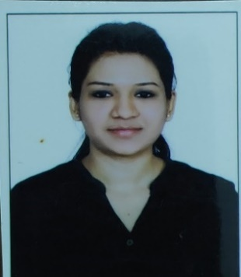ALIPUR PRAVEENA KUMARI



Nishachristopher8@gmail.com

C

O

N

T

A

C

T

M

E

A

T

S

K

I

L

L

S

S

U

M

M

A

R

Y

Interpersonal skills

Management skills

Communication skills

# C A R E E R O B J E C T I V E

**Work for an organization which provides me the opportunity to improve my skills and knowledge to growth along with the organization objective. A highly disciplined and hard-working individual looking for a responsible position to gain good experience. To explore the new areas and work in a dynamic stable organization**.

# I N T E R S H I P E X P E R I E N C E

Worked as an intern in feedback infra private limited for 3months.

Worked on preparation of request for proposal & petition documents in energy sector.

Demand assessment for energy sector project.

**Involved in preparation of tariff petition.**

**Certified in campus recruitment training on 16th November 2017.**

**Certified in basic photography.**

**Certified in film making course.**

**Worked in youngistan, NGO.**

E D U C A T I O N A L H I S T O R Y

**10th Passed from S.S.C Board with GPA of 7.3 in 2013.**

**12th Passed from Intermediate Board A.P(C.E.C) with 55% in 2015.**

**B.A (POLITICAL SCIENCE, MASS COMMUNICATION, COMMUNICATIVE ENGLISH) from VILLA MARIE DEGREE COLLEGE FOR WOMEN with 60% in 2018.**

**Pursuing PGDM (Energy and urban management & Marketing management) from Administrative staff college of India, Hyderabad in 2019 -2021 session.**

P R O F E S S I O N A L S Y N O P S I S:

B.A graduate with good interpersonal skills.

**Good communication skills.**

**Curious to apply Communication skills at management level.**

H O B B I E S & I N T E R E S T S

Photography enthusiast.

Travel and explore

Listening Music

Cooking

Sports -Badminton

E X P E R I E N T I A L L E A R N I N G (T R A I N I N G) :

Industrial Visit in AGI Glaspac, Hyderabad, Telangana.

**Industrial visit in chocolate factory.**

**Participated in INKWASH 2019.**

**Certified in Digital marketing.**

**Trained in Excel, Tableau, R-studio.**

P E R S O N A L M E M O R A N D U M

Father’s Name : A.CHRISTOPHER(LATE)

Date of Birth : 18th May 1958

Gender : Male

Languages Known : English, Hindi, Telugu.

Nationality : Indian

Religion : Christian.