Curriculum Vitae
------------------------------------------------------------------------------------------------------------------
Mohan Singh
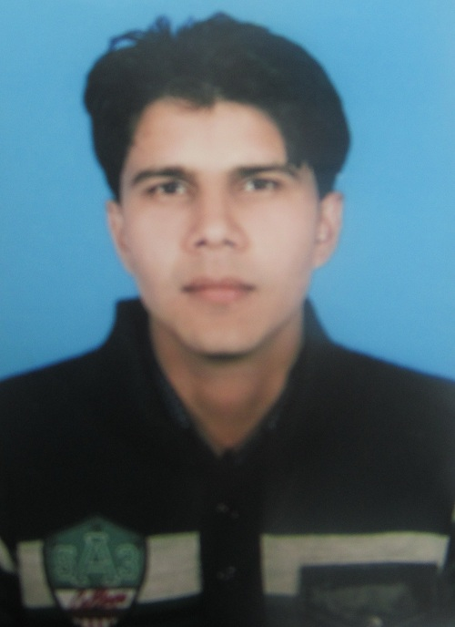
Mob: +91-9457385104,
Village – Nagar, Post office-Bichpuri
Dist – Agra, (U.P) 283105 Email: mohansingh0423@gmail.com

Objectives:-
- I am here to get the Success because Success is a Journey not a Destination and to become a Genius because Genius is nothing but the one who have a great aptitude for patients and great affords for their Goal.
Professional qualification:-
- I have done Completed Jetking Certified Hardware Networking Professional (JCHNP) Course from Jetking Agra
In-House Education
- M.sc (Physics) Completed Post Graduation from agra University with 64%
- B.sc (P.C.M) Completed Graduation From Agra University With 58%
- 12th passed from U.P. Board, in 2009 from AGRA with 66%
- 10th passed from U.P. Board, in 2007 from AGRA with 62%

WORKING EXPERIENCE
1. Company Name: SEA NETWORK Ltd. Agra
Position: IT Engineer
Experience : 3 year (2009 – 2012 )

PRESENT COMPANY INTRODUCTION: -

Sea Tv Network LTD.is a complete 24 hours high technology based Premium News Channel. Sea TV is currently broadcasting three satellite channel under the banner of Jain Telemedia services Ltd. Sea News (Uttarpradesh/Uttarakhand), Jinvani & Namokar One news Channel and two devotional channels presenting the Jain dharma.

2. Company Name: Aerial telecom Pvt.Ltd. (cisco router config)
Position: IT Engineer
Experience : 1 year

Responsibility : windows & Linux based systems & , Routers, Switch, Ethernet ,cisco router (asr 920) and Network etc.

3. Company Name: Epson (Bank barcoad passbook Print )
Position: IT Engineer
Experience : 1 year

4. Company Name : R.k net click
Position: IT Engineer
Experience : 1Year 6 month

5. Company Name : Outrageous Netsol Pvt. Ltd.
Position: IT Engineer
Experience : 1 Year 6 month

Responsibility : windows, Routers, Switch, Ethernet ,Gpone Olt, Epon Olt , Network etc.

Key Areas:

- Edius( FOR DUMP AND EDITING ) (installation and troubleshooting)

- Installation & troubleshooting of Standalone & Network printers.
- Crimped Direct and Crossover cables.
- Implemented SWITCHES
- Troubleshooting LAN problems.

- PC Assembling, Installing and Configurations of Network Hardware Devices and driver installation.

- All types of Desktop computer’s troubleshooting, recover data from Virus and, Windows and Internet level Security implementations.

Technical skills
- Installing & Configuring: WINS, DNS, Backup, Active Directory.

- Operating Systems : Installing, managing, and configuring, M.S, operating system, windows 98, windows XP, windows 7, 8, Linux (red hat), ubuntu , windows server 2003, windows server 2008

- Network : Switches, Router and all types of Structured Cabling.

Network Administration & Network Planning :
- Design a simple LAN
- Create an IP Addressing Scheme
- Install and configure a Network using TCP/IP
- TCP/IP Communication
- Subnet masking of IP networks.
- Manage system files

Future Planning
- I would like to go for the Advance Security Systems Up gradation and do something Special for the country.

PERSONAL INFORMATION
Hobbies
- Enjoy my Work.

- Working for being busy my-self and exploring what are the possible ways to do something new.

Personal profile:
- Father’s name: Mr. Gopal Singh
- Father’s mobile no. +91-9456620758,7668786480
- Mother ‘s name Mrs. Kamla Devi
- Date of birth: Aug-04-1990
- Marital status: Single
- Language known: English, Hindi
- Permanent address: Village–Nagar, Post Office-Bichpuri
Dist-Agra (U.P) 283105

I hereby declared that all above-mentioned information is best in my knowledge

Place:
(Mohan Singh)
Date:

