VARUN GOYAL
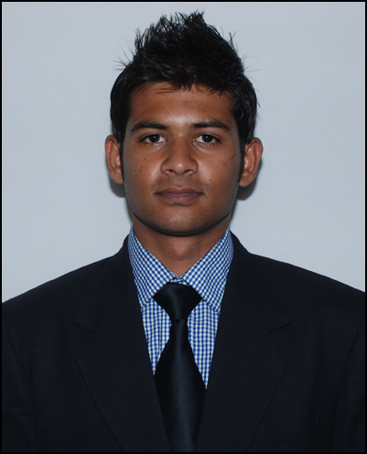

+91-8273151598/ 7017429140
varungoyal3231@gmail.com

CAREER OBJECTIVE
Seeking assignments in a challenging job environment that utilizes my skills and abilities opportunities to achieve organizational goals effectively and efficiently with the knowledge I have gained through my studies and experience.

RESUME SUMMARY
Committed, initiative taker, punctual, passionate, creative, team worker, quick & continuous learner, relationship building.

EDUCATION
• | 2013- MBA in Marketing from Alliance University | 1.8(69%)
• | 2011 – BBM from GARDEN CITY COLLEGE Bangalore, BANGALORE University | 66%
• | 2008 - Class 12 from NIRMAL DEEP PAGARANI PUBLIC SCHOOL , CBSE | 69.4%
• | 2006 - Class 10 from NIRMAL DEEP PAGARANI PUBLIC SCHOOL, CBSE | 59.8%

EXPERIENCE SUMMARY
Business Development Executive –Pace Securities(Mar2018- july2019)
- Managing the High Net Worth customers and all walk in customers in the branch.
- Handle and maintaining all walk in customers of branch.
- Contribution in achieving business targets of branch of Mutual funds, Insurance of the branch.
- Search and Recruit of agents. Who sale life Insurance, mutual funds and collect documents of customers.
- Handle branch staff and all employees and problems.
Self-employed (Jan 2016-Feb2018)
- Applied marketing for promoting the business.
- Handle full finance, marketing and operations. It include purchasing & selling of product and maintaining the stock.
Personal Banker- HDFC Bank ltd. (Aug 14- jan2016)
- Managing the High Net Worth customers of the Bank.
- Achieving the Business targets assigned in terms of cross selling, enhancing and upgrading the High Net worth relationships. Profiling Customers and provide financial products to meet customer needs.
- Ensuring the highest levels of service to the High Net Worth customers
providing financial planning & Investment Advice.
- Sales targets spread across Liabilities, Retail Assets, Business Banking, Forex, Credit Cards, Online trading
- One point contact for all requirements of High Net Worth customers in the Branch
Acquisition & Servicing of High Net Worth customers.
- Supervised implementation of banking centre service and sales operations.
- Met or exceeded annual sales goals on a regular basis.
- Trained junior staff in sales management, sales productivity.
- Oversaw branch audits.
- Back up for banking operations in the absence of operations employees.
Sr. Relationship manager- Bajaj Allianz Life Insurance co. ltd( Aug 2013- July 2014)
- Working in banc assurance channel (CITI bank) and sales only in IT corporates.
- Managing and building client and intermediary relationship for new business development and retention of the existing business.
- Arranging Client engagement programed to ensure customer retention.
- Monitoring delivery of high-quality customer experience, elevating customer satisfaction.
- Giving Presentation in induction for sales.
- Work on Lapse cases and convince them to reactivate their policies.
Business Development Executive -Your kids ‘R’ our kids(Mar2013- July2013)
- Sold company services to B2C & B2B and achieved a defined sales target.
- Identified customer needs and developed value added proposition proposal and pricing.
- Researched and identified market prospects and targets.
- Assessed clients need for services.
- Scheduled and arranged for new client appointments and calls for corporate tie-ups for employer-employee benefit program.

INTERESTS
- Playing and watching Cricket, Table-tennis, Football, Badminton
- Stock Market, listening & following current affairs and politics
- Movies and listening to music

PERSONAL DETAILS
Address | Shop A-23,new sabji mandi,haridwar road, near koyal grand,rishikesh-249201
Date of Birth | 3 January ,1991
Languages | English, Hindi

