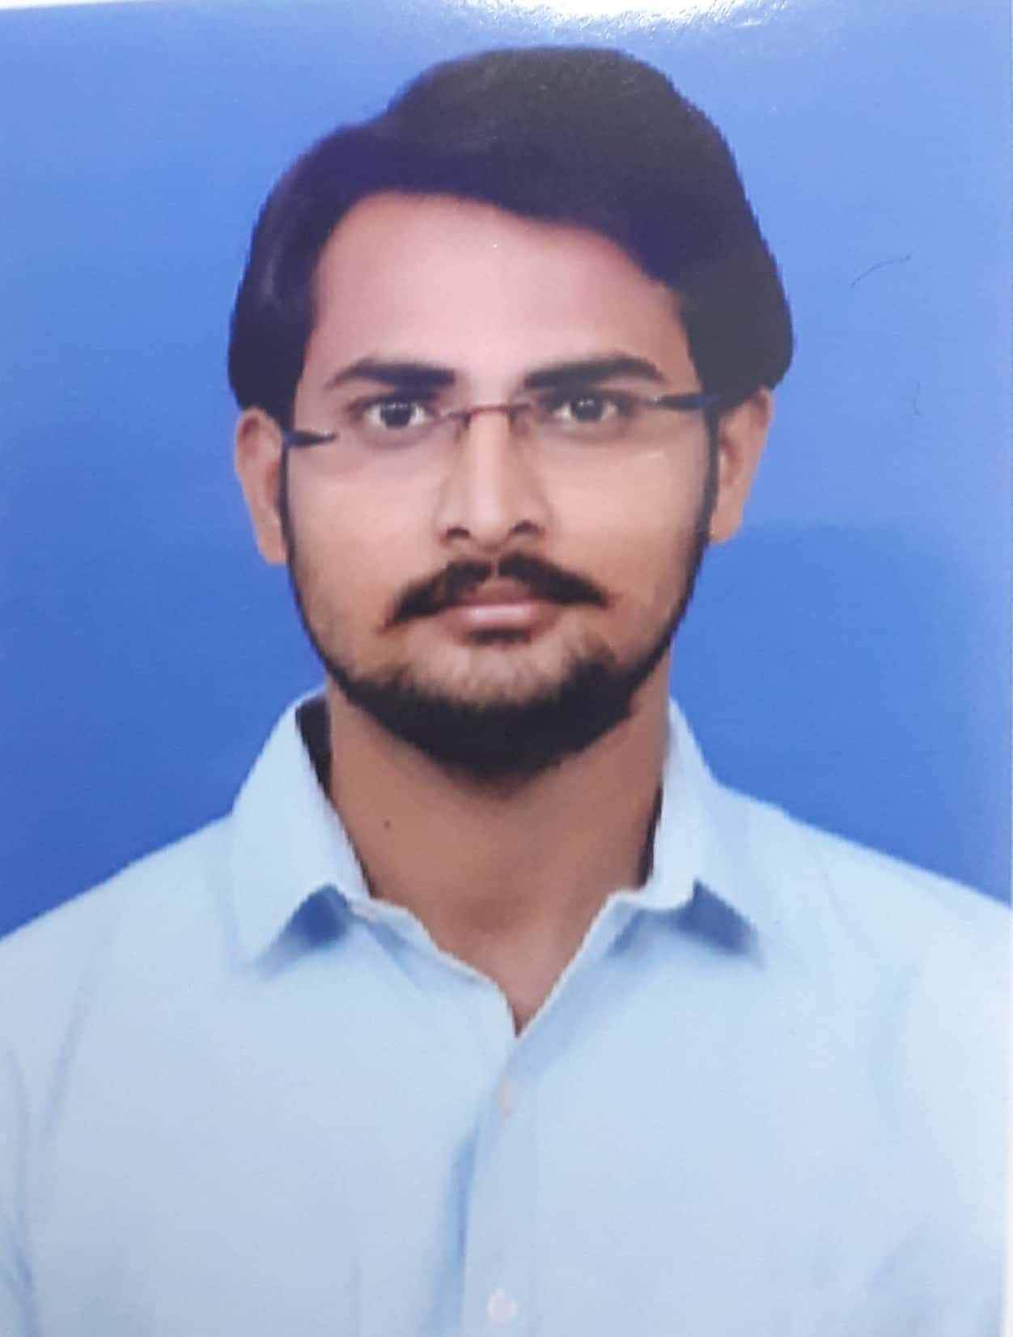

**Upender Reddy Ravula**

S/o R. Narender Reddy

# 5-42, V V Nagar Colony,

Mubharak Nagar (Vill)

Nizamabad, Telangana-503003

Email: ravulaupender08638@gmail.com

Contact Number: +91- 7386470321, +91- 8639543461



**CAREER OBJECTIVE:**

Seeking a quality environment that helps me to realize my dream of becoming a top class executive an organization that enriches my knowledge and sharpens my skills for mutual benefit.

|  |  |  |  |  |  |  |
| --- | --- | --- | --- | --- | --- | --- |
| **ACADEMICS** | | | | | | |
| **Course** | | **Name of Institute** | **Board/University** | **Academic Year** | **Aggregate** | |
| B Tech (CSE) | | Guru Nanak Institution of Technical Campus, Ibrahimpatnam | JNTU  Hyderabad | 2018-21 | - | |
| Diploma Civil Engineering | | Govt. Polytechnic College, Nizamabad | SBTET | 2015-18 | 73.5 | |
| SSC | | Kakatiya High School, Nizamabad | Board of Secondary Education | 2014-15 | 8.7 | |

|  |
| --- |
| **Projects & Achievements** |

**Floating Bridge:**

Mostly this bridge is used in long spans in water, where the construction of RCC bridges is risky. Period: 3 Months Team Size: 3 Mem

**Industrial Exposure:** Industrial visit at Sriram Sagar Project for 3 days in February 2017.

**Achievements:**

* In 2017, participated in Industrial training which is held by Nizamabad Municipal Corporation (NMC).
* Achieved AUTOCAD Certificate from Diploma College.
* Received Certificate of Polyskills from State Board of Technical Education & Training (SBTET) Telangana.

|  |
| --- |
| **SKILL SET** |

* Java
* Python
* Autocad
* MS-Office (Word, Excel, PowerPoint)
* Internet Applications.

|  |
| --- |
| **My Competencies** |

**STRENGTHS:**

* Good communication Skills.
* Patience.
* Adaptability towards the environment.
* Self-Motivational
* Quick Learner

**OTHER ACTIVITIES & HOBBIES:**

* Playing Table Tennis
* Playing Online Games

|  |
| --- |
| **Personal Profile** |

Father : Ravula Narender Reddy

DOB : 03-09-1999

Gender : Male

Marital status : Unmarried

Languages Known : English, Telugu & Hindi

Address : # 5-42, V V Nagar Colony, Mubharak Nagar

Nizamabad, Telangana-503003

I hereby declare that :

“All the statements made above are true to the best of my knowledge & Belief”.

Place : Hyderabad

Date : 02-11-2020 Upender Reddy Ravula