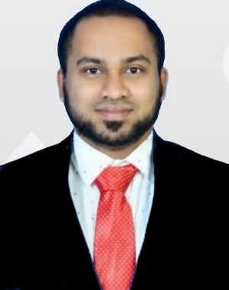  JACKY SHAN R  jackyshan109@gmail.com  +919677526704  LinkedIn ID:  linkedin.com/in/jacky-shan-1a995b1a1  Languages  Speak:  English, Tamil, Malayalam, Hindi  Write:  English, Tamil, Malayalam  Hobbies:  Photography, Kabaddi, Badminton, Travel, Drawing | Objective  To give my best performance and utilize my skills and knowledge to contribute to the organization success and to learn new skills for the betterment of myself.  Academic Qualification  Degree College/University Year Percentage  MBA Amity University 2019-21 Pursuing  BE Anna University 2012-16 6.78  Class XII SRKBVMHSS 2011-12 80.00  Class X SRKBVMHSS 2009-10 85.50  Professional Qualification  Master’s degree  Research: A study on New Product Development and Operational constraints in automobile Industry with special reference to Ford India  - Success of New Product Development on existing models in automobile industry  - Challenges in Operation  Bachelor’s degree  Research: Mechanical Behaviour of composite weld aluminium alloy AA6061 by FSSW  - A solid-state joining processes, no linear movement of the tool occur results in a localised ‘spot’ weld.  - In the automotive industry, the main push for FSSW is to minimize the welding time when compared to other processes.  Work Summary  Organization BLUE DIAMOND ENGINEERS.  Client RBSSN Pvt Ltd, Iron Ore mines.  Designation  (1) Site Engineer (Jun 2016- Dec 2017)  - Monitoring and evaluating underground performance.  - Ensuring that operations comply with the health and safety requirements.  (2) Production Engineer (Dec 2017- Jan 2019)  - Checking equipment’s and doing preventative maintenance to ensure it is in a good working condition.  - Producing products at an affordable pricing without having any negative impact on quality.  Interpersonal Skills  - Collaboration  - Active listening  - Team Building  - Social Skills  Technical Skills  - Microsoft Word, Excel, Power Point  - Power BI  - AUTO CAD  - SOLID WORKS  - Ansys  Extracurricular Activities  - Attended “Motivation of Youth for Inspiring Rural Development” a state level Symposium organized by the NSS Unit of SXCCE  - NSS camp coordinator and Mentor  - SXCCE Kabaddi team Captain

