**Hemant Prasad**

**Cover Letter**

**Applied Company – CANARA BANK**

November 30, 2020

CANARA BANK

Regarding: Manager or Senior Manager

Dear HR Manager,

As an aspiring and hardworking person, I know I have the capability to step into Manager Role and can make a positive impact on Canara bank’s goal. My record of work experience, academics, achievements and contribution to co-workers support a high level of dedication. I believe Canara bank and my career goals are a strong match for a successful future.

I am an aspiring leader and offer key strengths in leadership, communication and decision making. I am proficient at improving process and motivating teams to excel.

Being highly experienced in the requirements of this role, I see that you are looking for someone with skills in market penetration and data base management. I have learned a lot about Canara bank and believe with your team would be a reward for me.

Thank you for your time and consideration of my willingness in the Manager role. If you want to know more about my skills and knowledge feel free to contact me.

Sincerely,

Hemant Prasad

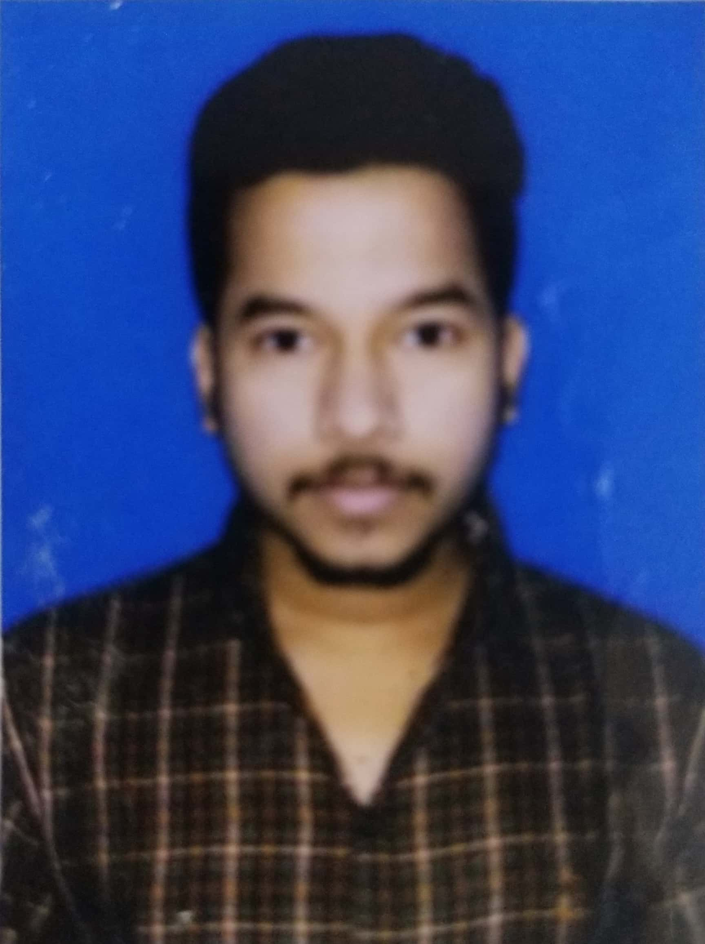

**Name : Hemant Prasad**

**Address : Chinakuri ½ pits colliery, Asansol**

**West Bengal - 713360**

**Mobile no : +91 - 9064563469**

**Email id : hemantprasad156@gmail.com**

**Linkedin : Hemant Prasad|Linkedin**

**D.O.B : 09.11.1996**

**CAREER OBJECTIVE:**

|  |  |  |  |
| --- | --- | --- | --- |
| **ACADEMIC CREDENTIALS** | | | |
| **Qualification** | **Institution/University** | **Percentage/CGPA** | **Year** |
| PGPM | ICFAI Business School- Mumbai |  | 2020-22 |
| B.Com | University of Calcutta |  | 2015-18 |
| HSC | Indian School Certificate |  | 2015 |
| SSC | Indian Certificate of Secondary Education |  | 2013 |

|  |
| --- |
| **WORK EXPERIENCE:** |
| **COMPANY NAME : TATA CONSULTANCY SERVICES**  **TENURE: 2years 3months**  **Work Involved:**  Factory Planner  MDM (Master Data Management) |

|  |
| --- |
| **COMPUTER LITERACY :** |
| MS Office (Word, Excel, Power Point, Outlook)  KnowledgeShare Point  Worked In MS Teams  Worked in SAP |
| **AWARDS AND ACHIEVEMENTS :** |
| BPS Star Performer Award  Beyond Performance Award  BPS Champions League - Team Award  Applause for Team Award |

|  |
| --- |
| **CO-CURRICULAR ACTIVITIES:** |
| I was a part of School Cricket team  I was a part of Indira HOUSE and we won inter relay of 500 meters  In College days during final year organized puja in college  Part of NGO named as TOT-Polio in school days |

|  |
| --- |
| **LINGUISTIC PROFICIENCY:** |
| English  Hindi  Bengali |

|  |
| --- |
| **HOBBIES & INTEREST:** |
| Playing Cricket  Playing Carom  Travelling |