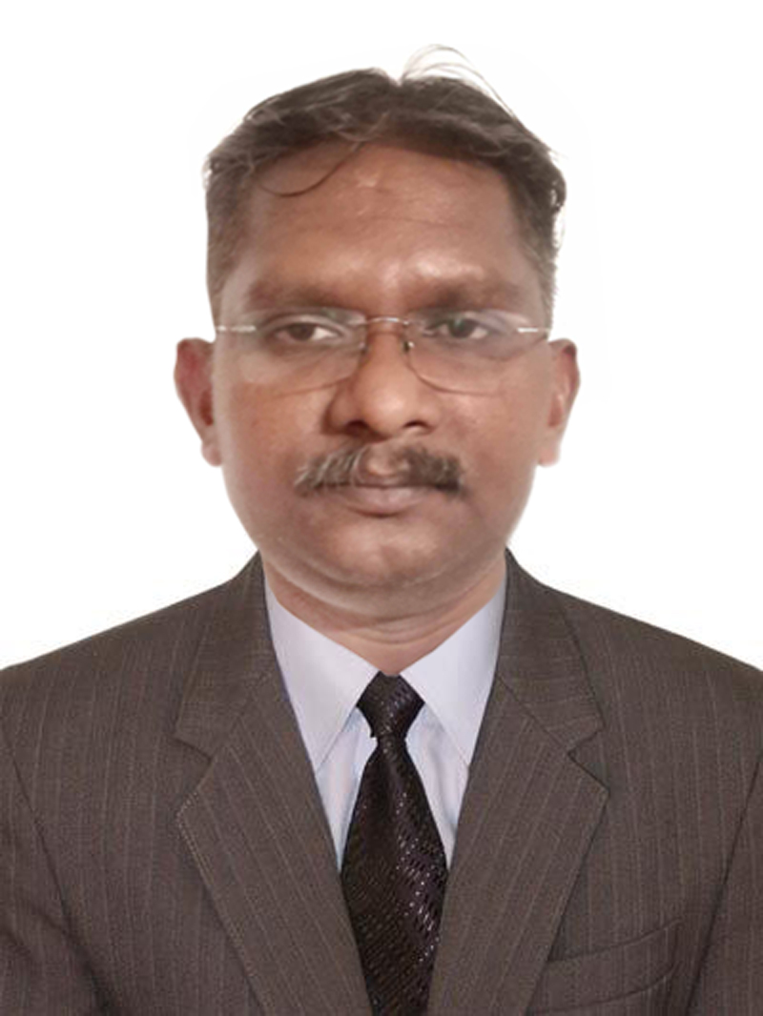 |  |  |  | VINOY KUTTAPPAN  Room No. 113, Persia N13,  International City, Dubai UAE  Ph: +971 551286494 / +971 55 8167154  kvinoy1975@gmail.com, skype: kvinoy19751
VISA STATUS
VISIT VISA
Date of Expiry: SEP 16, 2019
SKILLS
Executive Secretary | Personal Secretary | Personal Assistant | Executive Assistant | Secretary | Document Controller | Office Coordinator | Admin Assistant |
Language (English, Hindi, Tamil, Malayalam, Arabic (Beginner)) |
MS Office (MS Word, Excel, PowerPoint) | AutoCAD | PageMaker | CorelDraw | Photoshop | Illustrator and Basic in Tally & InDesign etc.) | MS Outlook |
Competent speed in Typing & Shorthand | Problem Solving | All Clerical Activities |
PERSONAL INFO  Date of Birth  2nd April 1975  Martial Status  Married  Father's Name  P.N. Kuttappan  Driving Lic. No.  (UAE) 2275510  Passport Details  No. L8908297  Date of Issue  22-04-2014  Date of Expiry  21-04-2024  Place of Issue  Cochin |  | WORK EXPERIENCE (OVERALL 15+ YEARS)
 |  | July  2016 to  Sep.  2018 | Executive Secretary & Proj. Officer  M/s. Ihsan Transport. & Gen. Contracting, Abu Dhabi.  - Managed MD’s appointments, Travel plan and relevant co-ordinations.  - Manage Ticketing and Travel Facilities.  - Planned conferences for Executives and Preparation of relevant documents and minutes of meeting.  - Updated day to day of Office & Projects developments and report to Managing Director.  - Recorded and typed minutes of meetings, using typewriter and computer  - Coordinated office activities and submitted reports to Managing Director.  - Maintained Proper filing of documents in a professional and systematic manner.  - Coordinating the Office Activities as well as Contract Section – Customers, clients, Purchase orders, Quotations etc.  - Managed proper utilization of time and expert in making appointments for the executives  - Coordinated and directed office services, such as records preparation, personnel, and housekeeping, to aid executives  - Maintaining and coordinated office supplies.  - Acted as a first point of Contact for the clients and contractors for smooth flow of Projects.  - Maintained and controlled all the relevant Documents in a systematic and professional manner.  - Proper maintaining of Inward & Outward Documents
Feb 2012 to  July 2016 | Executive Secretary-cum-Contract Coordinator  M/s. Al Asfour, Dammam, Saudi Arabia  - Managed MD’s appointments, Travel plan and relevant co-ordinations.  - Manage Ticketing and Travel Facilities.  - Planned conferences for Executives and Preparation of relevant documents and minutes of meeting.  - Updated day to day of Office & Projects developments and report to Managing Director.  - Recorded and typed minutes of meetings, using typewriter and computer  - Drafting and sending Correspondence via email and letters.  - Coordinated office activities and submitted reports to Managing Director.  - Maintained Proper filing of documents in a professional and systematic manner.  - Coordinating the Office Activities as well as Contract Section – Customers, clients, Purchase orders, Quotations etc.  - Managed proper utilization of time and expert in making appointments for the executives  - Coordinated and directed office services, such as records preparation, personnel, and housekeeping, to aid executives  - Maintaining and coordinated office supplies.  - Acted as a first point of Contact for the clients and contractors for smooth flow of Projects.  - Maintained and controlled all the relevant Documents in a systematic and professional manner.  - Proper maintaining of Inward & Outward Documents
May 2008  to  Sep 2011 | Administrative Secretary  M/s. Dolphin Steel Construction, Dubai  - Updated day to day of Office & Projects developments and report to Contracts Manager.  - Recorded and typed minutes of meetings, using typewriter and computer  - Drafting and sending Correspondence via email and letters.  - Coordinated office activities and submitted reports to Managing Director.  - Maintained Proper filing of documents in a professional and systematic manner.  - Coordinating the Office Activities as well as Contract Section – Customers, clients, Purchase orders, Quotations etc.  - Maintaining and coordinated office supplies.  - Acted as a first point of Contact for the clients and contractors for smooth flow of Projects.  - Maintained and controlled all the relevant Documents in a systematic and professional manner.  - Proper maintaining of Inward & Outward Documents
2007 to 2008  2006 to 2007  2000 to 2006  1999 to 2000  1998 to 1999 | Secretary-cum-System Admin.  M/s. St. Thomas Hospital, Changanacherry, India  Confidential Asst. to Magistrate  Munciff-Magistrate court, Erattupetta, Kerala  Secretary-cum-Instructor –  M/s. Pace Computer Education, Kottayam, India  Apprenticeship Trainee –  Indian Space Research Organization, Trivandrum  Trainee Secretary –  Indian College of Education, Kottayam, India
EDUCATION
Diploma In Commercial Practice 1998
Board of Technical Education, Kerala, India (A three year diploma course for business studies)
B.Com (Completed) 2004
Mahatma Gandhi University, Kottayam, India
Diploma In Computer Applications 2001
Private Institute @ Kottayam, India
Office Automation, Graphic Designing & Accounting (Tally) 1998
Private Institute @ Changanacherry, Kottayam, India
Fitter Trade (ITI) 1995
Govt. Industrial Training Institute, Chengannur, Kerala, India

About Myself
Self-motivated, proactive, a quick learner, highly organized and able to work on my own initiative with minimum supervision. Have Flexible working capacity in a dynamic and demanding environment and excellent communication, coordination skills and ability to deal confidentially with information, looking for a highly responsible position as per my qualifications & experiences in a well reputed organization where I will get a better chance to push my career and also an opportunity to prove my skills and abilities by providing accurate services towards the growth of the organization. 19 Year more Experienced, 3 Year Business/Secretarial Diploma holder, having strong foundation in SECRETARIAL / DOCUMENT CONTROLLER / CLERICAL/PERSONAL ASSISTANT positions. I am now seeking an apt position with your company so I can utilize my skills and build a career with you.

VINOY KUTTAPPAN
+971551286494

