CURRICULUM VITAE

WASIM AHMAD  Electrical & Automation Engineer in Rolling Mill  Diploma In Electronics | 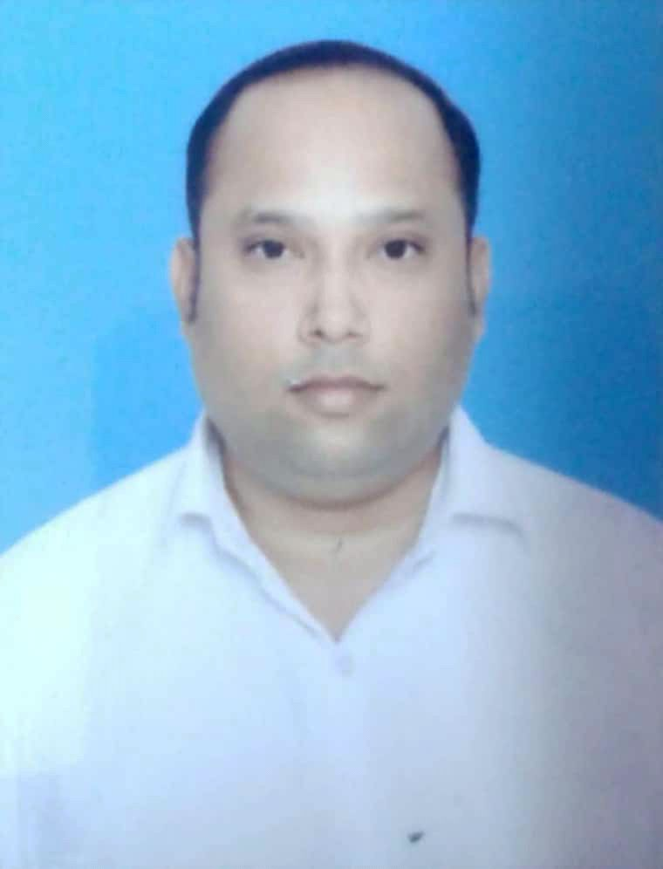
Summary
Seeking a challenging position in the domain of project Management, Commissioning, Erection & Maintenance of Electrical equipments, Commercial Operations & Quality in the organization that offers me generous opportunities in the field of Electrical Engineering.

Technical Expertise
- Worked in project of BAR MILL in which did the Erection of the electrical panel , input output testing of the signals, commissioning of the field instruments like Hot Metal Detector , Pressure switch, Proximity limit switch , solenoid valves , Shut off valve etc

- Worked in Wire Rod Mill having capacity of 0.6 mtpa which produce finished products from 5.5 mm to 22 mm. Having Knowledge of Process related automation.

- Worked in Central Utility Mils( CUM) in electrical and automation department, having knowledge of ICW, DCW, Compressed air circuits and process related equipments.

- Working in Siemens PLC SIMATIC-S7400 & S7 300 series.

- SIEMENS SINAMIC S120 AC drives

- Electrical Control Circuit and Remote Input Output (RIO).

- Process Data Acquisition unit.

- Knowledge on continuous operation of BAR MILL.

- Working as the Electrical shift Incharge.

COMPANY PROFILE
JINDAL STEEL AND POWER is having BAR ROLLING MILL of MORGAN and automation of SIEMENS. Rolling capacity of 1.2 MTPA. HYQST bar is produced. It is a slit type rolling mill having Power slitter, NTM, Switch Pipe, Divide Shear, RES with Moving Rake for rolling Rib Bar up to 20mm. Above 20mm till 40mm RIB and Round rolling (20-63 mm) is done from centre rolling line with divide shear and brake slide system.
WIRE ROD MILL of capacity of 0.6 MTPA. This Mill is capable of rolling round wire rod from 5.5mm to 22.0mm.This mill have NTM, RSM, Temperature control water boxes (METCS), Laying head, Cooling conveyor (Stelmore) and Coil handling area including pallets, C hooks and compactor .

BAR MILL Furnace designed by FIVE STEIN with capacity of 200TPH having walking beam cycle time 35 seconds.

RESPONSIBILITY
- I was involved in the commissioning activity of SIEMENS PLC S7 400 and S7 300 series.
- Is able to develop programme in PLC as per operational requirement and Rolling schedule generation.
- Is able to generate the HMI pages for the client HMI. Authorization of client to accesses specified authority of the area.
- Is able to configure Engineering station, HMI server and client. Generate server and client pages using Visual Basic.
- Is able to use the IBA analyzer (PADU) for troubleshooting during the cobble for analyzing the root cause. And make modification required for the process so that problem does not repeat with same reason. Use same tool to maximize the mill utilization.
- Have knowledge on SINAMICS S120 AC drives.
- I am involved in analyzing the problem and resolving them to run mill at rated capacity and maximum utilization of mill.
- Also involved in spares management, man-power planning, and plant to man safety.

Qualification

Exam Passed | Year of Passing | Institution Attended | Board/University | Result (%)
DIPLOMA IN  ELECTRONICS | 2010 | NETTUR TECHNICAL TRAINING FOUNDATION | NTTF | 80.8
MATRICULATION | 2005 | Netaji Subhas Public School | CBSE | 58.6

COMPUTER SKILLS:
Object oriented language : C++
Operating System : Windows-98, XP,
Window- 2007-2008
Other package : MS- Office.

STRENGTH

- Good communication, analytical and logical skill.
- Active team player and quick learner, adapting to align situation easily.
- Self-Motivate, “Never Say Die “Spirit.
- Hard Working Ability.
- Quick adaptability to new technology.
- Being result oriented and the ability to meet deadlines.
- Build and maintain relationship.

Personal Profile
Name : Wasim Ahmad

Father's Name : MR. Suhail Ahmad
Date of Birth : 2nd April 1990
Sex : Male
Marital status : Married
Religion : Islam
Nationality : Indian
Passport Details : M1941495
Language known : English, Hindi,Urdu
Hobbies : Music & Games
Permanent Address : E-65, Sector-2, Jindal Steel and Power Campus, Balkudra, Patratu, Jharkhand, India.
Email ID : ahmadwasim94@gmail.com.
Skype ID: 9771437487
M.No : +91-9771437487, 6205895760
Present CTC: 5.65 lacs p.a
Expected CTC: as per company norms
Notice Period : 1 MONTH
Location Prefered: Anywhere in IND& Abroad

Place: JSPL Patratu. Wasim Ahmad.

