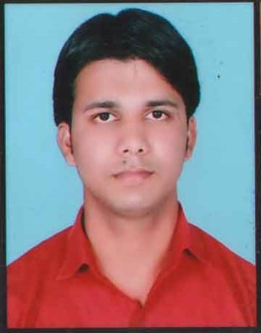**Resume**

***ABDUL REHMAN***

***S/o Sh. Mohd. Yaqoob***

***R/o Moh. Pathanpura, Mehandibagh,***

***Najibabad, Distt. Bijnor (U.P) Pin:-246763***

***Email Id:Abdulrehman30892@gmail.com***

***Mob.No.: 8923786841,* 6395624554**

*To achieve the target and goal with professional and creativity aspire to rend quality service and world like to devote my capability and abilities of working and dedication towards my responsibilities and challenge.*

**OBJECTIVE**

**QUALIFICATION**

* High School passed from U.P Board in 2010 .
* Intermediate Passed from U.P Board in 2012 .
* B.Com from M.J.P.R.U Bareilly in 2015
* M.Com From M.J.P.R.U Bareilly In 2018

**COMPUTER SKILLS**

* I Have Good Knowledge Of Office Automation Software (Ms.Office)
* I Have Good Knowledge Of Windows & Software
* I Have Good Knowledge Of Computer Network( Routing & Switching )
* I Have Good Knowledge About Internet (Protocols)
* I Have Good Knowledge About Ecommerce Company
* Diploma in Telecom sector
* Tally knowledge
* One Year Diploma in Computer Hardware & Networking
* CCC (Course On Computer Concept)
* I Have done Consignment Tracking Executive Course

**WORKING EXPERIENCE**

2 Year Experience Computer Hardware & Software Trainer In IFCT Computers Pvt Ltd

2 Year Experience Network Technician As well as Trainer In Horizon Skills Pvt Ltd

1 Year Experience Office Executive in Horizon Skills Pvt Ltd

**PERSONAL PROFILE**

Father’s Name : Shri Mohd. Yaqoob

Date of Birth : 30th Aug, 1992

Gender : Male

Marital status : Unmarried

Nationality : Indian

Language known : Hindi, English & Urdu

**DECLARATION**

I here by declare that all the above information is true to the best of my knowledge & belief.

Date ………………... Signature

Place……………….. **(ABDUL REHMAN)**