CURRICULUM VITAE

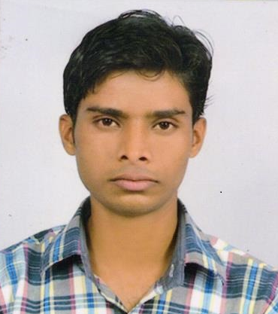  FAIZAN FAREED ANSARI  Email: ffansari12@gmail.com  Address For Communication:  77 Sultanpur Bhawa,  Allahabad-211003 [U.P]  Contact No.: +91 7754915185  Permanent Address:  77 Sultanpur Bhawa,  Allahabad-211003 [U.P]  Personal Information:  Date Of Birth : 17 July 1993  Father’s Name : Mr. Mohd. Fareed  Ansari  Sex : Male  Nationality : Indian  Marital Status : Unmarried | OBJECTIVE  To work in a reputed organization with my education qualifications and skills, I believe in hard work and produce better result in admirable atmosphere.  EDUCATION QUALIFICATION:  - Post Graduation (M. Com) Passed with Ist division from University of Allahabad in 2015.  - Graduation (B. Com) Passed with IInd division from University of Allahabad in 2013.  - Intermediate Passed with Ist division from U. P. Board in 2010.  - High School Passed with IInd division from U. P. Board in 2008.  TECHNICAL QUALIFICATION:  - Computer Operator and Programming Assistant (COPA).  - One Year Diploma in Computer Application, in Dec 2013.  - Six months Computer Diploma in D. T. P. (Desk Top Publishing) in 2011.

COMPUTER PROFECIENCY:

- MS Word, MS Excel , Online transactions, Working knowledge in Tally ERP 9

WORK EXPERIANCE:

- Working at “Chandra Packaging Industries” Naini Allahabad as Accountant from 15 March 2017 to Till Now.
ROLE & RESPONSIBILITY:

- Journal Entries
- Purchase
- Sales
- Account payables
- Account receivables
- Bank reconciliation
- Maintain worker’s salary

PROFESSIONAL PROFILE:

- Results-oriented with good interpersonal skills.
- Highly flexible and adaptable performer.
- Exceptionally motivated self-starter who works hard and loves a challenge.
- Enthusiastic communicator with proven analytical skills to develop detailed reports.
- Proactive, positive approach. Able to grasp/learn concepts and procedures quickly.

DECLARATION:

I hereby declare that the above-mentioned information is correct up to my knowledge and I bear the responsibility for the correctness of the above-mentioned particulars.

Place: Allahabad Faizan Fareed Ansari

