**APURBA RANJAN BHUYAN**

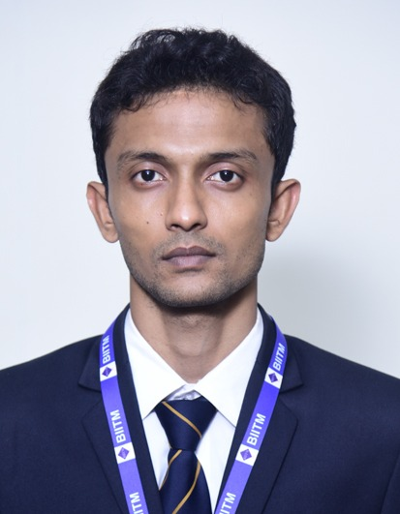

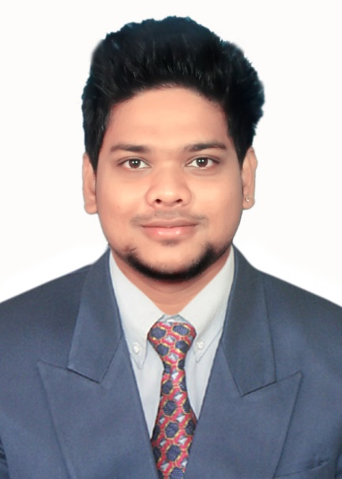

At/Po – Amrutapur, Bhadrak ,Odisha pin- 756129

Ph: 9324700853 **;** [apurbabhuyan1996@gmail.com](mailto:apurbabhuyan1996@gmail.com)

**CAREER OBJECTIVE**

Seeking a position to begin my career in a high-level professional environment. Value-driven and detail-oriented and curious to learn while implementing my excellent communication, leadership and managerial skills.

**SUMMER INTERNSHIP PROGRAM (SIP)**

**Company Name:** **M/S Flipkart India Private Limited, Kolkata, India.**

**Duration:** 45 Days

**Position:** Intern (Supply Chain Management)

**Objectives of the SIP:**

* Being a part of **Launchpad Internship Programme** **learn about the nuances of supply chain and** gained a deep supply chain experience during Big **Billion Days**.
* Adhere to 5S and process compliance, Engage and responsible for issue resolution & escalation matrices.

**Key Learnings:**

* Engage in Inbound & Outbound Operations on the floor and ensure the process and product & package movement is within TAT.
* Monitoring Loading and unloading activities, Tracking the various activity of manpower and documentation and reporting to the authority .

**Company Name:** **M/S FinSkool, Faridabad, India.**

**Duration:** 45 Days

**Position:** Intern Equity Advisor

**Objectives of the SIP:**

* Fundamental of investment specially reference to NSE and BSE strategies and prepared reports for client review meetings and fundamental analysis for various equity share.
* Advising clients with regards to their investment in the equity & derivative market and involved in an equity advisory, B2B & B2C sales of financial securities-related products & services.

**Key Learnings:**

* Fundamental Analysis of Equity share special reference to NSE & BSE.
* Concept of Nifty 50 companies.

**PROFESSIONAL EXPERIENCE**

Involved as a Design & Development Engineer in **M/S Classy Kontainers**, Mumbai. The job responsibilities involved from **16/04/2018 – 28/04/2020**;

* Prepare, approve and review the product design and test plans.
* Work with the manufacturing department to ensure that the packaging designs are optimized for manufacturability for big companies like **Asian Paints, Kansai Nerolac, PI Industries Ltd. , Dabur, Rallis India and J.K. Helene Curtis**.
* Responsible for managing multiple projects simultaneously.

**Extra Responsibilities:**

* Developed patented models of **‘TRU-GRIP’** series assigned by **Asian Paints**.

Involved as a GET in **M/S Yash Seals Pvt. Ltd**, Mumbai. The job responsibilities involved from  **01/09/2017 – 09/04/2018**

Roles & Responsibilities:

* Reviews the design and also indulged with manufacturing team over the making process of clamps, jigs& general tooling.
* Acquiring knowledge of CNC Machine Techniques, EDM Spark Machine and Lathes & mills.

**EDUCATIONAL QUALIFICATION**

|  |  |  |  |
| --- | --- | --- | --- |
| **Qualification** | **Board / University** | **Institution** | **Year** |
| MBA  B.Tech (Mechanical Engineering)  12th (Science)  10th | BPUT , Odisha  BPUT , Odisha  CHSE , Odisha  BSE , Odisha | Biju Patnaik Institute of IT & Management Studies, Bhubaneswar  Bhubaneswar Engineering College , Bhubaneswar  Bhadrak Junior College, Bhadrak  Shiva Durga High School , Panchapara | 2022  2017    2013  2011 |

**SEMINAR / WORKSHOP**

* Attended 1 day seminar on Management Principle of **‘** **The Dabba wala’** in the year 2021.
* Attended 2 day work shop on basics to **‘Digital Marketing’** organised by ‘Qreative’ in the year 2021**.**
* Attended 1day work shop on **‘Careers in FMCG’** organised by ‘Direction one Consulting’ in the year 2021**.**

**COMPUTER PROFICIENCY**

* Operating System : Windows , XP , Ubuntu.
* Computer Skills : MS Word , MS Excel , MS Power Point, MS Access & Digital Marketing.
* Software : Solid Works , Auto Cad ,Tablue & R Programming .

**EXTRACURRICULAR ACTIVITIES/AWARD RECEIVED**

* Participated as a Volunteer in **SAVE THE TIGER** campaign, Bhubaneswar, Odisha in 2015 organised by **Aircel Odisha Trade Partners**.

**PERSONAL INFORMATION**

Father Name : Late Mr. Amulya Kumar Bhuyan

Mother Name : Mrs. Jharana Bhuyan

Name : Apurba Ranjan Bhuyan

DOB : 14th June 1996

Nationality : Indian

PAN : BUTPB0972L

AADHAR : 7172 4203 1659

Blood Group : B+ve

Hobbies : Solo Traveller, Cricket.

Language Known : Odia, Hindi, English

**Date:**

**Place: Bhubaneswar APURBA RANJAN BHUYAN**