CURRICULUM VITAE

**RAVI KANT**

42 SANT NAGAR NEAR

NEAR AIR FORCE GATE, 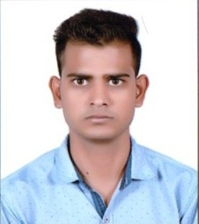

IZZATNAGAR BAREILLY

CONTACT NO: **8909140003/9457833427**

EMAIL:-**kantr303@gmail.com**

**CAREER OBJECTVIE**

A well mannered nature as well as practical in life. My career ambition is to work in a reputed organization and put the best possibilities effort to achieve the organization’s goal and to serve the industry with my best abilities to attain the heights of a successful career and to accolade in the world.

**EDUCATION QUALIFICATIOLN-:**

* High school from U.P. Board in 2010
* Intermediate from U.P Board in 2012
* B.sc Math from Monad university (Hapur) in 2015

**OTHER SKILL**

Hindi Steno 90wpm and Hindi/English typing 30 wpm and 40 wpm and certificate basic knowledge of computer.

**Experience**

**Three year experience in office work (Ms. Word, Ms. Excel, Ms. Power point) and continue working in sigma MRI diagnostic center Bareilly (Sep.19.2020…….continue )**

**PERSONAL DETAILS-:**

**Father’s Name** :: KESHAV DEV

Date of Birth :: 01 may 1995

Gender :: Male

Marital :: Single

Nationality :: Indian

Religion :: Hindu

Language known :: Hindi and English

Hobbies :: Reading newspaper

**DECLARATION**

I here my declare that all statement made in this application are true complete correct to I best of my knowledge and belief.

Date: DEC.30.2021

(RAVI KANT)

Place: Bareilly