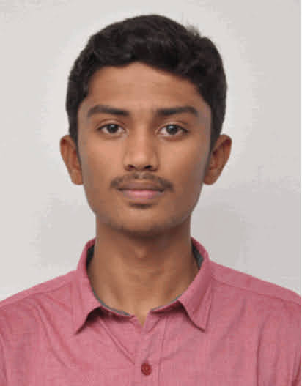

**CERTIFICATES**

**WORKSHOPS**

GCT - Machine Learning 101 2019

GCT - Ethical Hacking 2020

**INTERNSHIPS**

PANTECH - FUTURE SCOPE OF

e LEARNING ENGINEERING IN

GLOBAL DEVELOPMNET

2020

PANTECH - MATLAB

e LEARNING PROGRAMMING 2021

**WEBINARS**

NOVI TECH - TECH AWARE'21 2021

EDUREKA - FULL STACK WEB DEVELOPMENT

2021

**AREA OF INTEREST**

* WEB DESIGNING
* PROBLEM SOLVING
* APPLICATION DEVELOPMENT

**ARAVINTH CHINNA SAMY**

**BACHELOR OF COMPUTER SCIENCE AND ENGINNERING**

**ABOUT MYSELF**

I'm Aravinth 22 year old , I have completed degree of Computer Science in Velalar College of Engineering and Technology in Erode who is passionate about programming languages and finding solutions for real world problems.

**CAREER OBJECTIVES**

As a beginner in Industrial field, I would like to build my career and make my best use of analytics, logical, knowledge and skills to perform the success of the company.

**PROJECTS**

**EDUCATION**

SSLC - KONGU VELLALAR MATRIC.SEC

SCHOOL

2015 89%

HSC- SHRI GANGA HIGHER.SEC SCHOOL

2017 86%

B.E., - VELALAR COLLEGE OF

CSE ENGINEERING AND TECHNOLOGY

2021 79 %

**PROGRAMMING LANGUAGE**

C 90%

C++ 90%

JAVA 80%

PYTHON 30%

HTML 85%

**CONTACT DETAILS**

64,KUMMAKAALIPALAYAM VADAMUGAM VELLODE,PERUNDURAI,RS.ROAD, PERUNDURAI.638052.

8973996270

[aravinthc18@gmail.com](mailto:aravinthc18@gmail.com)

<https://github.com/postbox-18>

<https://www.linkedin.com/in/aravinth-c-806049204/>

* **Women Safety Management Android Application**

Using GPS, SMS, Google Sign in

* **Alumni Application Android Application**

Using Firebase Authentication, Cloud Storage, Real-time Database, Storage

* **Text-Recognition & Google Search**

Using Gallery/Camera, Google Search

* **Firebase Blog**

Using Real-time Database, Storage

* **Smart Ration Card System**

Using IOT, A Arduino,Embedded C, Database - Mysql

**DECLARATION**

I hereby declare that all the above-mentioned information is true and correct to the best of my knowledge.

**PLACE E-SIGNATURE**

ERODE aravinthc