RESUME

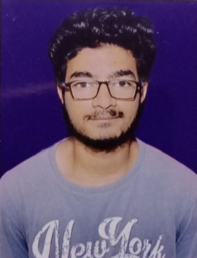

**Name: Ajay Prashad**

**Permanent Address: V-Dhulai (Pallidhar),**

**Ghorakhal, P.O.: Bhowali**

**(263132), Distt.: -Nainital**

**Correspondence Address: New I.T.I. Campus,**

**Rampur Road, Haldwani**

**Mobile No.: +91 7669773212**

**Email:** [**ajayarya044@gmail.com**](mailto:ajayarya044@gmail.com)

Father’s Name: Mr. Rajendra Prashad

Date of Birth: 19.02.2000

**Education Qualification:**

* 10th passed from UK Board with 58% marks on 2015.
* 11th passed from UK Board with 62% marks (PCM group) on 2016.

**Additional Qualification:**

* NCC ‘B’ Certificate with ‘A’ grade.

**Current Qualification Status:**

* Doing Diploma with Civil Engineering from Govt. Polytechnic College Dwarahat , Almora.
* Completed 4 Weeks Training on “AUTOCAD” at Government Polytechnic Dwarahat delivered by SLOG SOLUTIONS Pvt. Ltd
* Awaited for result.

Nationality : Indian

Languages Known : Hindi & English

**Declaration:**

I hereby declare that all above furnished information is true to the best of my knowledge and if given an opportunity I promise to give the best abilities to the Organization.

Thanking You

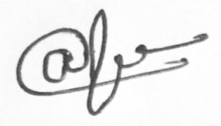Date: Your’s Faithfully

(Ajay Prashad)