**:: RESUME ::**

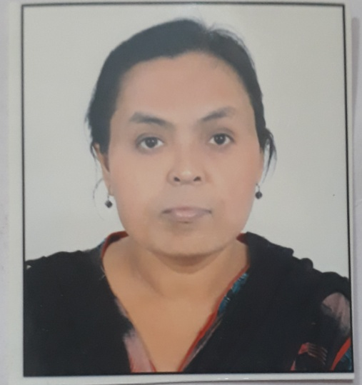 **VandanaChikate**

a/4 Arjun Vihar,Heerapur Road,

mohoba Bazar.Raipur(C.G.)

Pin-492099

**Contact No**. : 8975434362

**Email-id** : Vandanachikate80@gmail.com

|  |
| --- |
| **Personal Information -** |

Name : VandanaChikate

Date of Birth : 21Feb 1980

Gender : Female

Nationality : Indian

Marital Status : Single

Permanent Address : a/4 Arjun Vihar,Heerapur Road,

mohobaBazar.Raipur(C.G.)

Pin-492099

Current Adderess : Near bus stand bokardan (Jalna)

Cast। : S.C.

Telephone No . : Mobile-8975434362

Email :. vandanachikate80@gmail.com

Linguistic Ability : Hindi

Hobbies : Listening Music

Work Experience : Librarian in Rajkuwar Collage Bhokardan(Jalna) from

1 year.

|  |
| --- |
| **Educational Qualifications -** |

|  |  |  |  |
| --- | --- | --- | --- |
| **Qualification** | **Board/University** | **Year of Passing** | Percentage |
| M.LIB. | Nagpur university(Maharashtra) | 2018-19 | 69% |
| Certificate in Nursing assistant | Nagpur university(Maharashtra) | 2017 | 78.75% |
| BLIB | Mahatma Gandhi Hindi Visav Vidhayalay Wardha(Maharashtra) | 2013 | 59.25% |
| MA(HINDI) | Raipur university(C.G.) | 2008 | 56.70% |
| BA | Raipur university(C.G.) | 2006 | 44.16% |
| HSC | Jabalpur | 1998 | 45.1% |
| SSC | Jabalpur | 1996 | 56.4% |

I hereby declare that the above written particulars are to the best of my knowledge and belief.

**Date:16 /08/2020**

**Place:Bhokardan ,Jalna(Maharashtra)**

**(VandanaChikate)**