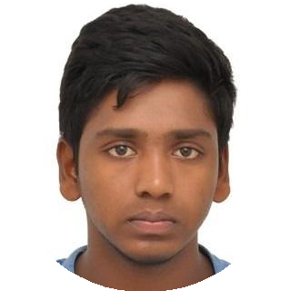Venkat Tanneru

It Recuriter
Enthusiastic communicator and eager to contribute to team success through hard work, attention to detail and excellent organizational skills. Clear understanding of others and conﬁdent replying and also with good pace of communication. Motivated to learn, grow and excel in Team management.

venkytanneru@gmail.com 07995953397 Quarters, Dr No:236/F, Medical College Road, India

EDUCATION

Degree

Hindustan Institute of Technology and Science
SKILLS
Good communiaction
Eﬀective Listener

07/2016 – 04/2020
Bachelor of Technology
Aeronautical Engineering

Higher Secondary Education

Sri Chaitanya Institute
06/2013 – 07/2015
Chennai,India

Vijayawada

LANGUAGES
English
Native or Bilingual Proﬁciency

INTERESTS

Hindi
Full Professional Proﬁciency

Reading Books
Solving math

