CURRICULUM VITAE

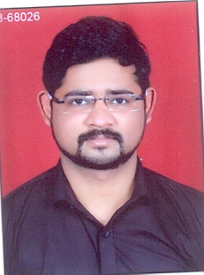
SHUBHASH KUMAR SHAKY
Address:- H.No.16, Street No.4, Kolipura Barkhedi,
Bhopal (M.P.)
E-Mail:- shubhashkumar35@gmail.com Contact No:-9806422473

OBJECTIVE:

To secure a challenging position where I can effectively contribute my skills as Professional, possessing competent Technical Skills and to develop myself and my organization.

ACADEMIC QUALIFICATIONS:

S.NO. | CLASS/COURSE | BOARD/UNIVERSITY | YEAR OF PASSING
1. | M.B.A | B.U UNIVERSITY | PURSUING
2. | B.COM | B.U UNIVERSITY | 2018
3. | 12TH | M.P BOARD | 2012
4. | 10TH | M.P BOARD |  | 2010

PROFESSIONAL QUALIFICATION

- English & Hindi typing pass from S.V Poly College, Bhopal.
- Tally ERP9 passed from S.V Poly College, Bhopal.

WORKING EXPERIENCE:

- I worked as sales executive (10 months) in Apps Daily Mobile Insurance Company.
- I worked as service manager (15 months) in Good Auto Mobiles.
- I worked as Manager in L.B.S HOSPITAL as a Floor Manager (FM).

ADDITIONAL EXPERIENCE CERTIFICATES:
- Training Certificate 1 month in DTE of SATPURA BHAWAN, Bhopal.
- Microsoft virtual Internship certificate 2020.
- Google Digital Garage certificate 2020.

PERSONAL SKILLS:

Comprehensive problem solving abilities, excellent verbal and written communication skills, ability to deal with people diplomatically, willingness to learn team facilitator hard worker.

PERSONAL PROFILE:

Name : Shubhash Kumar Shaky

Father’s Name : Mr. Nathu Singh Shaky
Mother’s Name : Mrs. Suman Singh Shaky
Date of Birth : 17/07/1993
Gender : Male
Marital Status : Unmarried
Nationality : Indian
Permanent Address : H.No.16, Street No.4, Kolipura Barkhedi, Bhopal
Mobile Number : 9806422473
Pin Code : 462008
Languages Known : English and Hindi

DECLARATION:

I hereby declare that the above mentioned information is correct up to my knowledge and I bear the responsibility for the correctness of the above mentioned particulars.

Place: Bhopal
Date : (Shubhash Kumar Shaky)

