**CURRICULUM VITAE**

**VIJAYKUMAR KANAIYALAL SUTHAR**

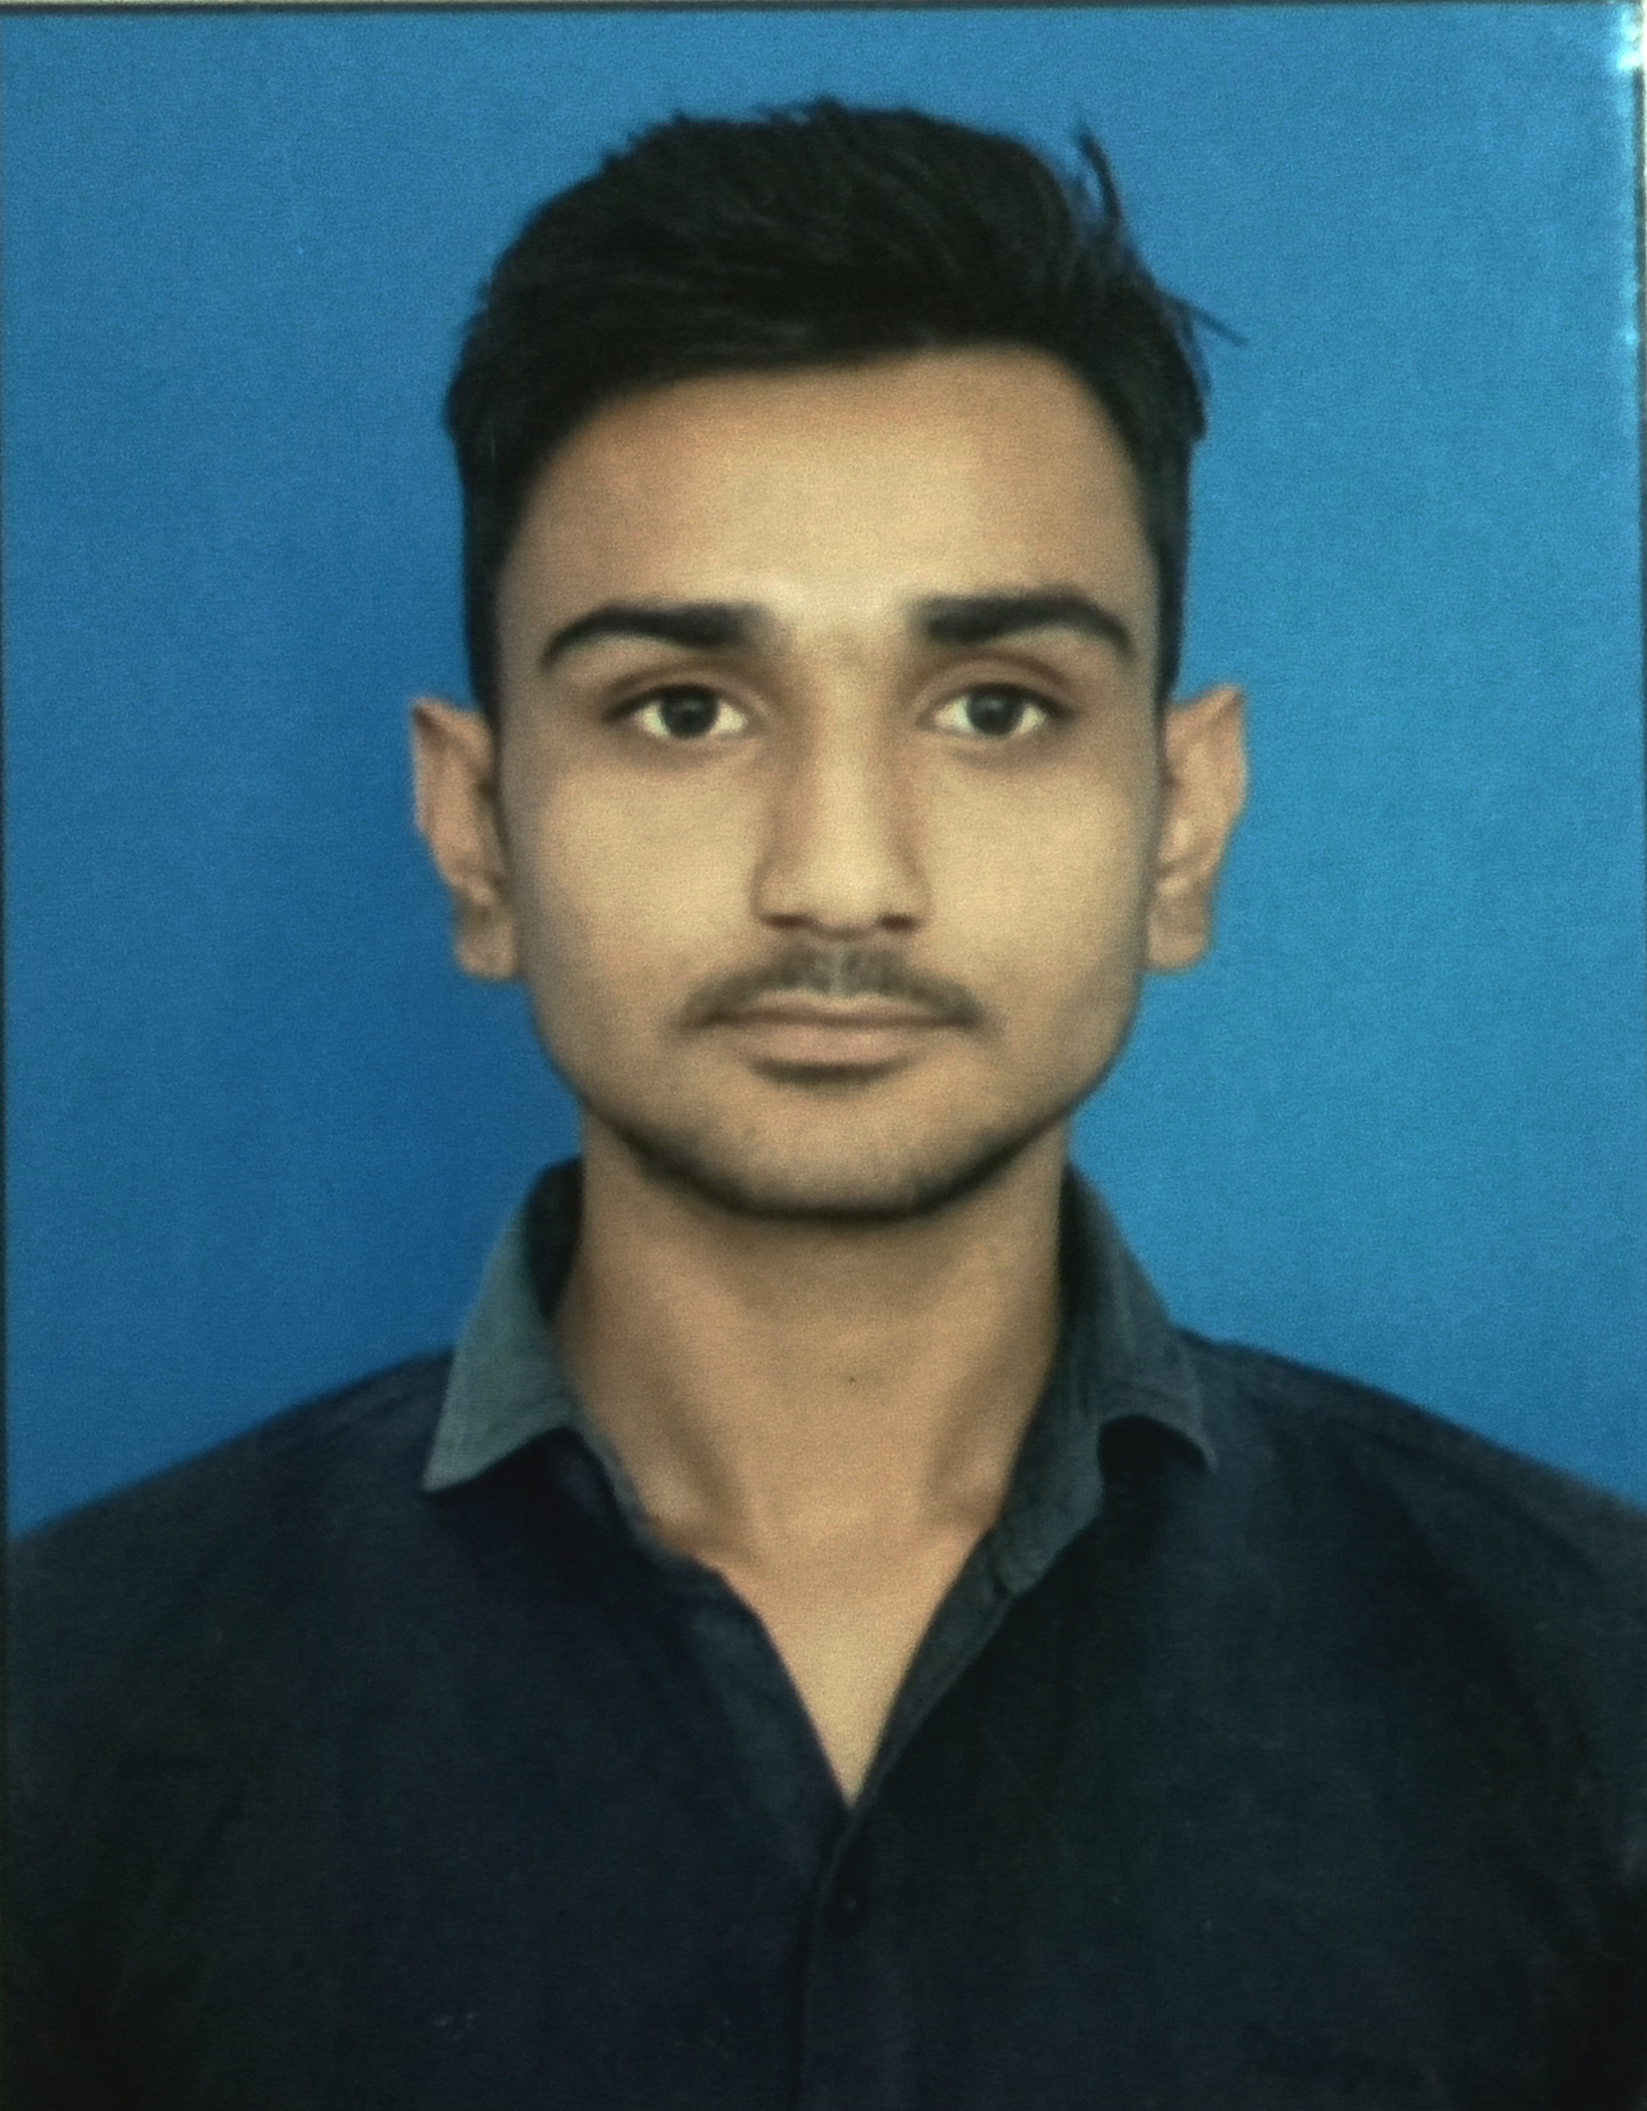

189-KH,DANGALAVAS,

RANGAKUI,

TA – VISNAGAR, PIN-384315

Email : sutharv37@gmail.com

Contact : +91 97375 66212

# CAREER OBJECTIVE

Workaholic personality in any type of work. I am curious to teaching. I am also curious to learn different types of knowledge from different subjects.

**EDUCATION**

|  |  |  |  |
| --- | --- | --- | --- |
| Course | Institute | Year of  Passing | CGPA / PER./GRADE |
| MASTER OF SCIENCE | M.N. COLLEGE,VISNAGAR  ( H.N.G.U. , PATAN ) | 2019 | 71.25 % |
| BACHELOR OF SCIENCE | M.N. COLLEGE,VISNAGAR  ( H.N.G.U. , PATAN ) | 2017 | 68.5 % |
| HSC | GSHSEB | 2012 | 71.33 % |
| SSC | GSEB | 2010 | 78.40 % |

# Work Experience

* Soil analysis under **Soil Health Card project** work of agriculture department,govt. of India in year 2018-19.
* Working as a computer operator in the GEMI project for **BMW**(Bio-Medical Waste) survey in Mehsana district.
* Working for GSHSEB for the analysis of DVD checking of 12th arts and commerce exams.

# Field of Interest

* Teaching
* Team Management
* Research

# SKILLS

* Sufficient Knowledge of Computer
* Handle instruments

# STRENGTHS

* Patience
* Communication
* Hard worker
* Good Observer

# PERSONAL DETAILS

* + Date of Birth : 4th Sept., 1996
  + Gender : Male
  + Marital Status : Single
  + Nationality : Indian
  + Languages Known : Gujarati, Hindi & Sufficient knowledge of English

# Declaration

I, **Vijaykumar K. Suthar**, hereby declare that the information contained herein is true and correct to the best of my knowledge and belief.

Date: 1st January, 2021

Place: VISNAGAR

**(Vijaykumar K. Suthar)**