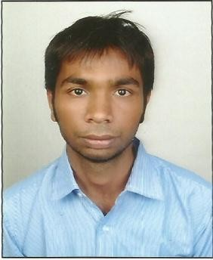
NEELESH CHOUDHARY

Mobile: +91 8233046931

Email: choudharyneelesh93@gmail.com

CAREER OBJECTIVE: Seeking a rewarding & challenging career as a professional in your company while dispensing my maximum potential for benefit of organization and at the same time acquiring knowledge on the road to success. I will keep learning strategies to handle and understand market and improvement of my skills related with your company domain.

STRENGTHS:
- Quick Learner to the given domain.
- Can work as Team Leader.
- Good presenting Skills.
- Intellectual.
- Good Analytical and Logical Skills.

TECHNICAL SKILLS:
Microsoft Office tools: MS Word, MS PowerPoint, and MS Excel.

WORK EXPERIENCE
. Worked as a post of “Project Coordinator & Supervisor” in BNRJ BULID GROUP , Udaipur, Rajasthan. (October 2016 to October 2020)
. Worked as a post of “Mechanical Engineer" in JK Tyre Industry Limited, Kankroli, Rajasthan. (September 2015 to September 2016)

INTERNSHIP
- 1 month winter internship held in Ambuja Cement Plant Jodhpur. (December 2013 to January 2014)

- 1 month summer internship in Hella India, Gurgaon involving
mechanical designing and implementation on machine in forming vehicle switches and horns. (15th July 2014 to 15th September 2014)

PROJECTS:
Pickup Robotic Arm based on Servo Motors.

WORKSHOPS / SEMINARS ATTENDED:
Attended 5-days” Robotic Workshop” in college.

HOBBIES & INTERESTS:
- I am quite desperate about Cricket which is my favourite sports, action to play and even watching Cricket Matches on TV.

- I love to have hangout with my friends, exploring new places, kind of so foodie.

- In my mean time I love watching movies which gives some meaningful end.

EDUCATIONAL QUALIFICATIONS:

B.Tech in Mechanical Engineering

Year | Course | Percentag e | Institute/College | Board/University
2009 | 10th | 65% | Vidhya Niketan Senior Secondary School | RBSE
2011 | 12th | 45% | Alok Senior Secondary School | RBSE
2015 | B.Tech | 58% | Faculty of Engineering | Pacific University

PERSONAL INFORMATION:
Date of Birth: 01st July, 1993
Father’s Name: Mr. Pushkar Lal Choudhary
Address: 60 A, Hiran Magri, Sector-3, Opposite BSNL Office, Udaipur (Raj.)
Languages Known: English and Hindi

DECLARATION:
I hereby declare that all above mentioned information is true to the best of my knowledge and belief.

Date: ..................... Neelesh Choudhary

