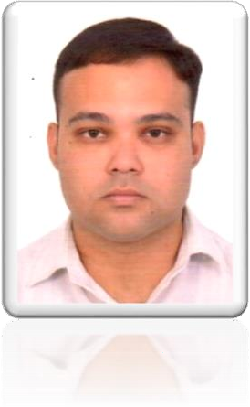

**MOHIT THAKURI**

*Email:* [*mohitfuture@gmail.com,*](mailto:mohitfuture@gmail.com) *Phone No: +919997313214*

*Address: H. No 371 A, Garhi Cantt Dehradun-248003 (Uttarakhand)*

***Work Experience: -***

|  |  |  |  |  |  |
| --- | --- | --- | --- | --- | --- |
| **S .No.** | **Organization/Department/ Office** | | **Job Title** | **Time Period** | |
| 1. | Commercial Tax Department (Govt. of Uttarakhand) | | Data Entry Operator | July 2007 to  Jan 2009 | |
| 2. | Indian Military Academy (Govt. of India) | | Office Clerk | Sep 2009 to  Feb 2012 | |
| 3. | North Point Children’s Academy (Affiliated to CISCE) | | Office Clerk | July 2012 to  Nov 2014 | |
| 4. | Seven Oaks School (Affiliated to CISCE) | | Secretary to Principal | Nov 2014 to  Dec 2015 | |
| 5. | Uttaranchal University | | Secretary to Dean | Jan 2016 to  March 2017 | |
| 6. | Army Public School Birpur | | LD Clerk | April 2017 to  March 2018 | |
| 7. | Indian Society of Remote Sensing | | Office Secretary | May 2018 to Till Date | |
| ***Educational Qualifications: -*** | | | | | |
| **S. No** | **Class** | **Qualification** | **Board/University** |  | **Year of Passing** |
| 1. | Graduation | Bachelor of Arts | HNB Garhwal University | | 2013 |
| 2. | XII | Sr. Secondary | National Institute of Open Schooling | | 2010 |
| 3. | X | I.S.C.E | Council for Indian |  | 2004 |
|  | |  | School Certificate |  |  |
|  | |  | Examination |  |  |
| ***Other Qualification:-*** | |  |  |  |  |

1. Six months computer certificate in Office Automation.

***Skills: -***

* **Software**: MS Office, MS Excel, MS Power point, MS Access Database, Outlook, Email, Internet Search and Surfing, EPF, ESIC, Basic Accountancy, Typing (English & Hindi), Letter Drafting, Documentations, Online Form Feeling, Windows and Software installations etc.
* **Hardware**: Basic Knowledge of handling PC and other computer peripherals like printer, scanner, photocopier etc.

**Personal Details**

1. Date of Birth : 11 December 1988
2. Father’s Name : Nb. Sub. Raman Singh (Retd)
3. Marital Status : Married
4. Languages Known : Hindi, English, Nepali & Punjabi
5. Nationality : Indian

**Declaration: -**

I hereby declare that the information provided by me is true the best of my knowledge.

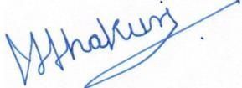

Date: November 12, 2020 (Mohit Thakuri)

Place: Dehradun