**RESUME**

1. 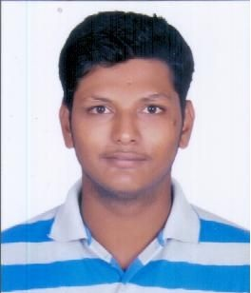Personal Details:-
2. Name:- Satyesh Raghunath Kodalkar
3. Address: - 159/9, Maharashtra Chawl,

L.B.S. Road, Kurla West,

Mumbai – 400070

1. Mobile No: - +91 8108664190
2. Email ID: - [skodalkar@gmail.com](mailto:skodalkar@gmail.com)
3. Position Sought: Civil Project Engineer.
4. Career Objectives: -

* Looking for the challenging job where I can utilize my talent and knowledge; and want to learn from the organization and growth with organization.

1. Educational Qualification: -

* Completed **Bachelor of Civil Engineering Degree** in 2017 from **Datta Meghe College of Engineering Airoli (Mumbai University).**
* Completed three years **Civil Engineering diploma** including one year inplant training program in 2014 from **Fr.Agnel Polytechnic Vashi** with **First class distinction with 82.58% aggregate.**
* Passed SSC examination in 2010 with 62% Marks.

1. Professional Qualification: -

* Undergone one year inplant training program on a construction site

At **Rustomjee urbania Thane project.**

* Completed **Autocad 2D Design and Drafting** program From the Government recognized training center Called **Cadd Center** located at vashi.

1. Experience: -

* Currently working as a Civil Site Engineer with M/s. G & G Construction, Mumbai on Various Government Undertaking Projects.
* On site Residential building construction execution experience with Mirador Dwellers pvt.ltd. , Mumbai as a Junior Site Engineer.
* Civil Engineer with one Year inplant training Experience of execution on actual site.
* Project Name – Rustomjee Constructions Thane, Rustomjee Urbania Project, Acura Building.

1. Special Skills: -

* Can operate general software’s and programs on computer very easily.
* Can operate MS Office word and Excel in well defined manner.

1. Declaration:

I hereby declare that all the details furnished above are true to the best of my knowledge and belief.

Date: - 25/09/2019

Satyesh R. Kodalkar

Place: - Mumbai.