|  |  |  |
| --- | --- | --- |
| **Name** | **:** | **Aditi Sinha** |
| **Date of birth and age** | **:** | **10/03/1997 23 years** |
| **Specialization** | **:** | **Finance** |
| **Phone** | **:** | **9902603901** |
| **Email** | **:** | **Aditisinha5678@gmail.com** |

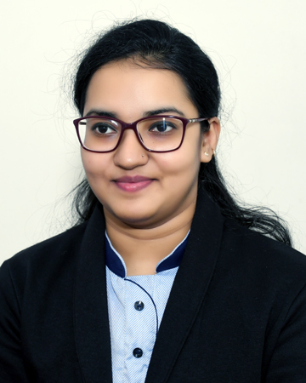

**Photo (Go to insert and click on picture)**

**CAREER OBJECTIVE**

Intend To Build a Career With Leading Organisation Working With Committed And Dedicated People Seeking New Challenges Which Will Help Me To Explore Myself Fully And Realise My Potentials. “There is always a better way of doing things” is the common belief.

**EDUCATION**

|  |  |  |  |  |
| --- | --- | --- | --- | --- |
| **Year of Completion** | **Course Studied** | **Name of the Institution / University** | **Major Subject Studied** | **Percentage** |
| 2021 | PGDM AIMA | Ramaiah Institute Of Management Studies (ALL INDIA MANAGEMENT ASSOCIATION) AIMA | Finance | 70.75% |
| 2018 | B.COM | M.S.Ramaiah college of Arts Science And Commerce. (BANGALORE UNIVERSITY) BU | Banking & insurance | 65.43% |
| 2015 | 12th | Delhi Public School(D.P.S) Panipat Refinery Township Haryana  (CBSE) | Commerce | 61.33% |
| 2013 | 10th | B.R.DAV Public School Barauni Refinery Township (CBSE) | science | 56% |

**INTERNSHIP/ PROJECT**

|  |  |  |  |
| --- | --- | --- | --- |
| **Company Name** | **Date** | **Project / Internship Title** | **Project / Internship Description** |
| 1.JMarathon Advisory Services pvt ltd. | 28/5/2020 (To) 13/7/2020 | Financial Analyst | Learned About “Basis Of Indian Stock Market And International Currency Market” |
| 2.All India management association(AIMA) | 29/6/2020 (To) 11/8/2020 | Virtual Internship | Gained knowledge about company how to design product price and marketing strategy with issued stock in the market. |

**CERTIFICATION**

* Financial Analyst Certification from  **Udemy**
* Have Undergone Through The Course Of “TALLY ERP9” From **Aptech**

**IT PROFICIENCY**

* MS Office
* Typing Speed

**EXTRA CURRICULAR ACTIVITIES**

* Participated as a “Speaker” for the seminar on the Topic **“Employability Of Management Graduates-challenges and opportunities : A students Perspective”**
* Volunteered **Blood Donation Camp** Conducted By M.S.Ramaiah College Of Arts Science And Commerce
* Attended the seminar on the topic **“VUCA WORLD”**
* Member of **Rotaract Club RIMS** (2019-2021)
* Participated In Debate For **Inter Dps Fest** Conducted In School
* Attended skill workshop conducted by **“VEDH ACADEMY”**

**PERSONAL DETAIL**

|  |  |  |
| --- | --- | --- |
| Gender | **:** | Female |
| Marital Status | **:** | Single |
| Father Name | **:** | Rakesh Kumar Sinha |
| LinkedIn Profile |  | www.linkedin.com/in/aditi-sinha-15367a196 |
| Permanent Address | **:** | House NO- C/2181 Panipat Refinery Township Indian Oil Corporation Ltd.(IOCL) Haryana |
| Languages known | **:** | English, Hindi |
| Res. Phone | **:** | 9416400619 |

I hereby affirm that the information in this document is accurate and true to the best of my knowledge.

**Name Aditi Sinha**