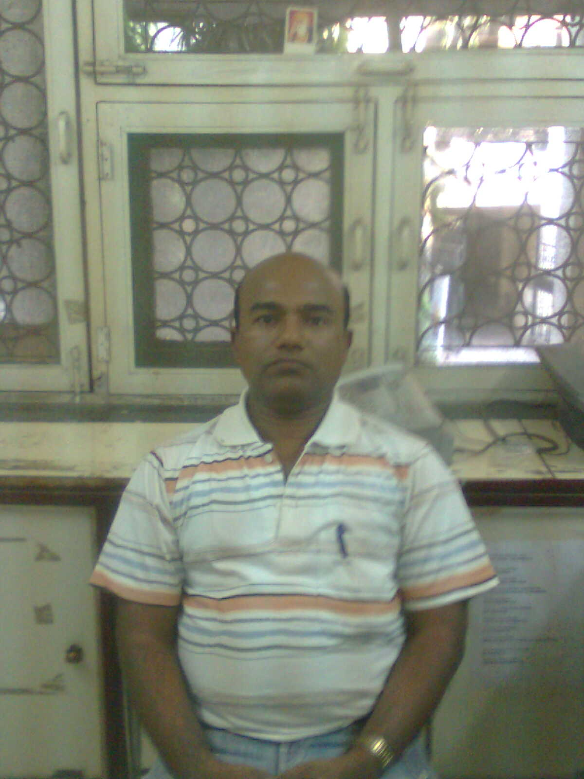

SANJEEV KUMAR SINGH
B-6/125, THIRD FLOOR
SECTOR-17, ROHINI
Delhi-, 110089
Mob.(R) 9871980091,9873937252
E-mail: kumar.sanjeev01977@gmail.com

CURRICULUM VITAE

Objective:
Looking after Daily needs of the Account in Firm & Company. I myself hereby verify that the facts stated above are true and correct according to best of my knowledge.
Qualification:
- Matriculation from Bihar School Board of Education Darbhanga in the session 1989
- B com. From L.N.M. University , Darbhanga, Bihar in the session 1995
Professional Qualification:
- One year’s Diploma in Computer & Financial Accounting.
- All Types of Accounts Books & Finalization of Accounting (Computerized)

Experience Details :
- Name & Address of Company :-
I) Anuj & Associates, DaryaGang, New Delhi-02, Jr. Accountant & Computer Operator from Dec.1999 to Oct. 2005
II) Gupta Exim (India) Pvt. Ltd. Faridabad, Haryana as a Jr. Accountant from Oct, 2005 to January-2008
III) Fab Knit India Pvt. Ltd.Karol Bagh, Delhi as a Accountant from January 2008 to May 2010
IV) Kangra Herb Private Ltd. Rohini, Pitampura as a Sr. Accountant from May 2010 to Nov-2012
V) Indian Herbal Store Pvt. Ltd, Model Town as a Sr. Accountant from Nov-2012 to till date.
Computer Skills:

- Basic of Computers
- Microsoft Office Package
- Tally Ver. (4.5, 5.4 6.3, 7.2 & 9-ERP) & Busy Dos. Version & Windows and Sigfa
- Operating Systems (windows 98, Windows Xp, Windows 2000, )
- Internet Access.
- All Documentation & Branch Accounting work.
- Export & Imports Related documentation

Job Profile:-

- Voucher making: Cash Voucher, Journal, Purchases , Sale Voucher & Inventory
- Vat Tax ( E-filling)
- Sale Tax – Refund & GST Refunds
- Assessments Case
- T.D.S.
- Service Tax
- Balance Sheet
- Trading Account
- Profit & Loss Account
- Bank Reconciliation
- ESI & P.F. Checking
- Export Documentation ( EDF & SDF Form)
- BRC issuing
- Handling Cash Activities
- Debit & Credit Note
- All GST Related Works
Hobbies

Listening Music and Dancing

Personal Information:

Father’s name : Lt.Mahendra Singh
Permanent Address : At +Po- Siso
Distt: Darbhanga
(Bihar)
Date of Birth : 27.03.1977
Sex : Male
Marital status : Married
Language known : English & Hindi
Nationality : Indian
CURRENT SALARY : 31000

EXPECTED SALARY : 35,000

NOTICE PERIOD : 5-10, DAYS
(Sanjeev Kumar Singh)

