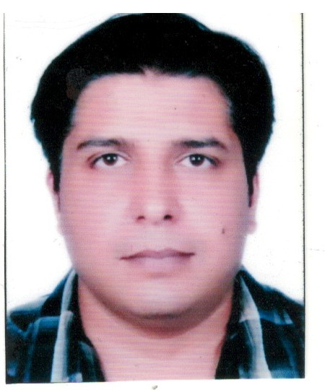SUMIT SHARMA
83/1, Bhandari Bagh, Near Vishvakarma Mandir, Lane - 8, Dehradun - 248 001
Phone: +91 9639004015, 8077622102 Email: roonit.vasistha@gmail.com, sumit_vasistha@rediffmail.com

OBJECTIVES:
To work in an organization where my work and efforts are rewarded with growth and responsibilities, thus growing along with the organization. I am seeking to further my career by way of enlarging the scope and depth of my responsibilities in a multinational company.
STRENGTH:
- Able to work under pressure of dead lines
- Willingness to learn
- Good communication skill
- Commitment, dedication, sincerity and diligence to the work at hand

PROFESSIONAL SUMMARY:

Y2K INFOSYSTEM- DEHRADUN Jan 2016 to till date

CYPRESS TRADESERVE PVT LTD May 2017 to June 2020

Account Manager

- Maintaining all Accounting books: Preparing monthly reports and providing financial information to the Directors after thorough analysis on the accounting data
- Prepares asset, liability, and capital account entries by compiling and analyzing account information.
- Documents financial transactions
- Summarizes current financial status by collecting information; preparing balance sheet, profit and loss statement, and other reports.
- Audit documents; collect, analyze and reconciles financial discrepancies
- Keeping financial information confidential and maintain up to date financial information
- Maintains financial security by following internal controls.
- Prepares payments after document verification and request disbursements
- Research and interpret sound accounting procedures, policies and regulations and recommends financial actions to the management.
- Good knowledge of local financial legal requirements and further study on the current and new legislation as required and shall advise management on needed actions.
- Collect, analyze and summarize account information and prepares special financial reports

OBERAI GROUP (DEALER-(DEALER-AUTOMOBILES (HYUNDAI, VOLKS WAGON, AUDI, GM, HONDA) DEHRADUN Jun, 2008 to 4, Apr 2016
Asst. Account Manager

- Expertise in Tally 9 Erp & Marg for the all the modules such as Accounts Payable, Accounts Receivable, Cash Management, General Ledger and Inventory Modules
- Experienced in preparing monthly financials like Trial Balance, Profit & Loss a/c, Balance Sheet, Cash Flow statement, Ratios and Analytical points on Financials.
- Expertise in monthly job analysis
- Expertise in preparing of weekly Bank, Cash positions and Cash Budget statement
- Experienced in preparation of monthly Bank Reconciliation statement
- Experienced in controlling Debtors & Creditors and preparation of debtors & Creditors Outstanding list and reporting to Management
- Well versed in preparation of department wise Monthly Collection Report.
- Expertise in reconciliation of receivable & payables with their respective statements

SHRI GURU RAM RAI INSTITUTE OF MEDICAL & HEALTH SCIENCES, DEHRADUN May’05 - Jun’08

Account Executive (Admin & Accounts)
- Preparation of bank reconciliation on daily basis.
- Preparation of debtors’ statements on weekly basis.
- Filling of TDS status in a System.
- Day to day Accounting transactions in Tally-9, Marg, HMS software.
- All the accounting related works.
ACADEMIC CREDENTIALS

M.B.A (FINANCE) 2009 -Mahatma Gandhi Kashi Vidhyapith (Varanasi)

M.Com. 2007 -HNB Garwhal University, , Dehradun

B. Com. 2005 -HNB Garwhal University, , Dehradun

Technical Skills
- Hands on experience in Tally (latest Version) also work in Marg other softwares.
- Good command over MS Office
- Well versed with Accounting/Taxation.

Articleship

3 years ICA article ship (Inter Training) at G K Patet & Company

FAMILY DETAILS

Father Name : Shri. Kailash Chandra Sharma (Ex Services Man-OFD Dehra Dun)
Mother Name : Smt.Uma Sharma (Housewife)
Spouse Name : Mrs. Taranjeet Sharma (Working as a Counselor in SGRRIMHS Dehra Dun)
Date of Birth : 20th July 1985
Languages Known : English, Hindi and Punjabi
Passport No : L9482698

DECLARATION
I hereby declare that the above mentioned details are true to best of my knowledge and belief

Place: DEHRA DUN (INDIA)

Date: 01/7/2020 SUMIT SHARMA

