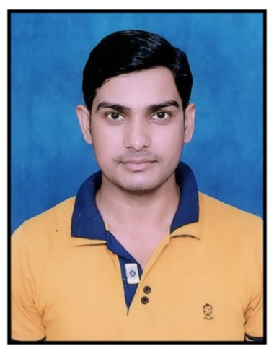***CURRICULUM VITAE***

* ***Name : Mr. Heera lal***
* ***Father’s name : Mr. Mahi lal***
* ***Date of Birth : 20-Jun-1992***
* ***Gender : Male***
* ***Nationality : Indian***
* ***Marital Status : Unmarried***
* ***Language Known : Hindi, English &Punjabi***
* ***Contact No. : +91-9927967391***
* ***E-mail :*** [***heeralal380@gmail.com***](mailto:heeralal380@gmail.com)

***Smoking : No***

***Alcohol Drinking : No***

***Hobby : Plying cricket, computer operating, hard working.***

***Permanent Address : Village -Bijiti, Post Office- Bijiti Patiya, Tehsil –Sitarganj, Distt. U.S.Nagar, (U.K.)262405***

***Present Address : Village -Bijiti, Post Office- Bijiti Patiya, Tehsil –Sitarganj, Distt. U.S.Nagar, (U.K.)262405***

***Educational Qualification : High School Pass from Uttarakhand Board in year 2008 with IInd Division.***

***: Intermediate Pass from Uttarakhand Board in year 2010 with IInd Division.***

***: Graduation (B.A.) passes from Kumaun University in 2013 with IInd Division.***

***: B.Ed passes in 2015-17 from Sushila   
 Tiwari B.Ed College Sitarganj (Kumaun   
 University) with Ist Division.***

***Other Qualification : CCC (Course on Computer Concept) passes In 2016 from National Institute of Electronics and Information Technology (NIELIT).***

***: IIBF (Indian Institute of Banking & Finance) Exam passes in 2019.***

***Computer Knowledge:***

* ***Basic Official Computer Knowledge.***
* ***MS-Office (Word, Excel).***
* ***Internet Knowledge.***
* ***Photo Shop.***
* ***E-Mail***

***Experience : Two Year Experience of Good Data operator or Basic and internet knowledge in Computer from Shivani Computer Bijiti or PAN CARD CENTER Sitarganj Uttarakhand.***

***Other Experience : 11 May 2016 to till date experience as a manager post on PAN CARD CENTER form Sitarganj, Udham Singh Nagar Uttraakhand 262405.***

***: April 2018 to till date experience of Address Verification Incharge Verification Manager in Udham Singh Nagar or Pilibhit District With Anaxee Pvt. Ltd Indore Madhya Pradesh.***

***: 2 Year Experience to till date as a Bank Mitra (B.C.) form Matiha, Bijiti with Bank of Baroda***

***Strengths:-***

* + ***Communicating Communication Skills.***
  + ***Flexibility and Adaptability.***
  + ***Learning ability: Quick learner.***
  + ***Tolerance: Stress tolerance.***
  + ***Critical thinking: Decision making skills.***
  + ***Creating Ideas: Creativity.***
  + ***Positive Attitude: Creating a positive work environment.***

***DECLARATION:***

***I hereby declare that my all above information are true and correct in the best my knowledge and belief.***

***Place – Bijiti, Sitarganj Heera lal***