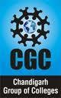
CHANDIGARH GROUP OF COLLEGES, Jhanjeri

…Building Careers, Transforming Lives
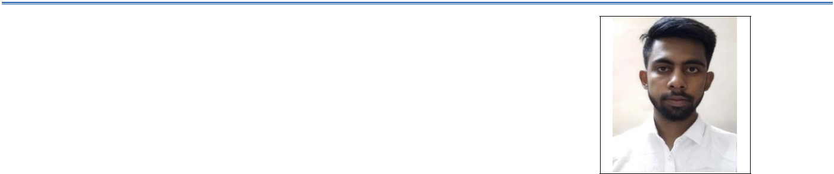

NAME
Gagandeep

Course: MBA
Specialization: Marketing & Finance.

Address: 93/4, Ram nagar Tohana, Haryana (125120)
Email: ggnbht22@gmail.com
Contact No: 9996561561

CARRER OBJECTIVE

To Achieve a good position in a well-known organisation for gaining experience by implementing my knowledge & skills practically.

ACADEMIC QUALIFICATION

Year | Course | Name of Board/University | %age
2021 | MBA | IKGPTU | Pursuing
2019 | BBA | KUK | 62
2016 | Sen. Secondary | HBSE | 73.4
2014 | Secondary | HBSE | 86

CORE MANAGEMENT COMPETENCIES

- Team Management

- Analytical Skills

- Presentation Skills

- Project Handling

- Client Reporting

- Friendly Behaviour

- Dedication in Present

- Pleasing and Positive attitude

- Ability to convince others

COMPUTER PROFICIENCY

- Basics of MS-Office (Excel, Word, PowerPoint & Outlook)

- Windows 7/8.1/10

- WordPress Development

CO-CURRICULAR ACTIVITIES

- Got 3rd position in Debate on Banking issues.
- Participated in Best Manager & Best CEO event in Gyan Manthan 2019.

- Secured 3rd Position in Paper presentation event.
- Participated in Business quiz in Digibration-2017 event held at MMU.

WORKSHOPS

- Participated in One day workshop on Personality development at IMS, KUK.

- One day workshop on “Banking in Digital Era” at IMS, KUK.

CERIFICATIONS

- 3 Months Advanced Digital marketing course

- Digital marketing Certifications of Google

INTERNSHIP PROGRAMME

- Company: Zimo Infotech LLP, Mohali
(Duration: 25-May-19 – 31-July-19)

Learnings during internship programme:
    - WordPress Website development
    - Email Marketing
    - Search Engine Optimization (SEO)
    - Keywords Research
    - Social media marketing
    - Calling to the Clients

- Company: Indiabulls Ventures Limited, Chandigarh (01-June-18 – 15-July-18)

Learnings during internship programme:
  - Stock Market Trading
  - Trading in Cash, Future & Options
  - Opening of Demat Accounts
  - Promotion of Mutual Funds
  - Cold Calling

HOBBIES

- Web Surfing

- Reading Books

- Information Seeker

- Networking

- Riding Bike

- Thinking Deeply.

PERSONAL DETAILS

DOB: 06-09-1999

Language Known: English, Hindi, Punjabi, Haryanvi

Current Address: #1215, Adarsh Nagar, Nayagaon, Mohali (160103)

Date:

Place:

Gagandeep

