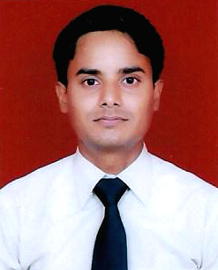

**CURRICULUM VITAE**

**SANJEEV KUMAR**

**13/240 TRILOK PURI DELHI 110091.**

**Contact No. : +919560165125**

**Email:** [**sanjeevconnectus@gmail.com**](mailto:sanjeevconnectus@gmail.com)

OBJECTIVE:

To work as a successful team member in a progressive and professionally managed organization and actively contribute to the growth and success of the organization, thereby achieve professional excellence.

EDUCATIONAL QUALIFICATION:

* 10th Passed from CBSE DELHI Since 2005.
* 10+2 Passed from NIOS DELHI Since 2007.
* Graduation from SHOBHIT University MEERUT Since 2013.
* M.A.(History) from IGNOU DELHI Since 2020.
* B.Ed Pursuing from CCS University.
* NCC “A” Certificate.

COMPUTER SKILLS:

* MS Office : Word Pad, Paint, MS Word, MS Excel, MS Power Point, Internet etc.
* Typing Speed : 35 wpm (English)

KEY SKILLS:

* Good communication skills.
* Can work effectively in team, as well as individually.
* Have good inter-personal skills.
* Quick learner and ability to meet tight deadlines and work under pressure.

EXPERIENCE:

* Working in Kailash Hospital & Heart Institute from 1st January 2010 to June 2016.
* Presently working in MoE from 1st July 2016 and still continuing.

HOBBIES:

* Listening Music.
* Playing Cricket

PERSONAL PROFILE:

Father’s Name : Late. Sh. Rajinder Singh

Mother’s Name : Late. Smt. Shobha Rani

Date of Birth : 10th October 1988

Sex : Male

Marital Status : Unmarried

Nationality : Indian

Linguistic Skills : Hindi, English

Passport No : K9476594

Date …………

Place………… **(SANJEEV KUMAR)**