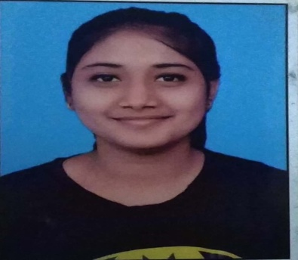

**Personal details**

Date of birth – 24/10/1999

Nationality –Indian

Permanent add. – 26, Trimurti nagar, Rajgarh (Dhar) M.P.

**HOBBIES**

* Cooking
* Art and Crafting work

**EXTRA CURRICULAR ACTIVITIES**

* Participated in Brand Management Workshop in college
* Participated in Green Olympiad
* Participated in Braintech India’s Mental Arithmetic Programme
* Won in long jump, volley ball and dodge ball in school

**LANGUAGES KNOWN**

* English * Hindi

**BBA**

**Parul University**

**6th sem**

CGPA : 7.15

**COMPUTER KNOWLEDGE**

* Sound knowledge of MS Word, MS Power point
* Good Typewriting speed
* Well experienced with use of internet
* C,C++

**2016-17**

S.R.V. Sanskar Dham

**HSC (Commerce with Computer Science (C++))**

Board : CBSE

Aggregate : 70%

**PERSONAL QUALITIES**

**2017-2020**

**EDUCATION**

**2014-15**

S.R.V. Sanskar Dham School

**SSC**

Board : CBSE

CGPA : 8.6

**OBJECTIVE**: To be part of an organization where I can fully utilize my skills and make a significant contribution to the success of the employer and at the same time my individual growth.

* riturathore805@gmail.com

 (M) 9098317751

**Ritumbhara Rathore**