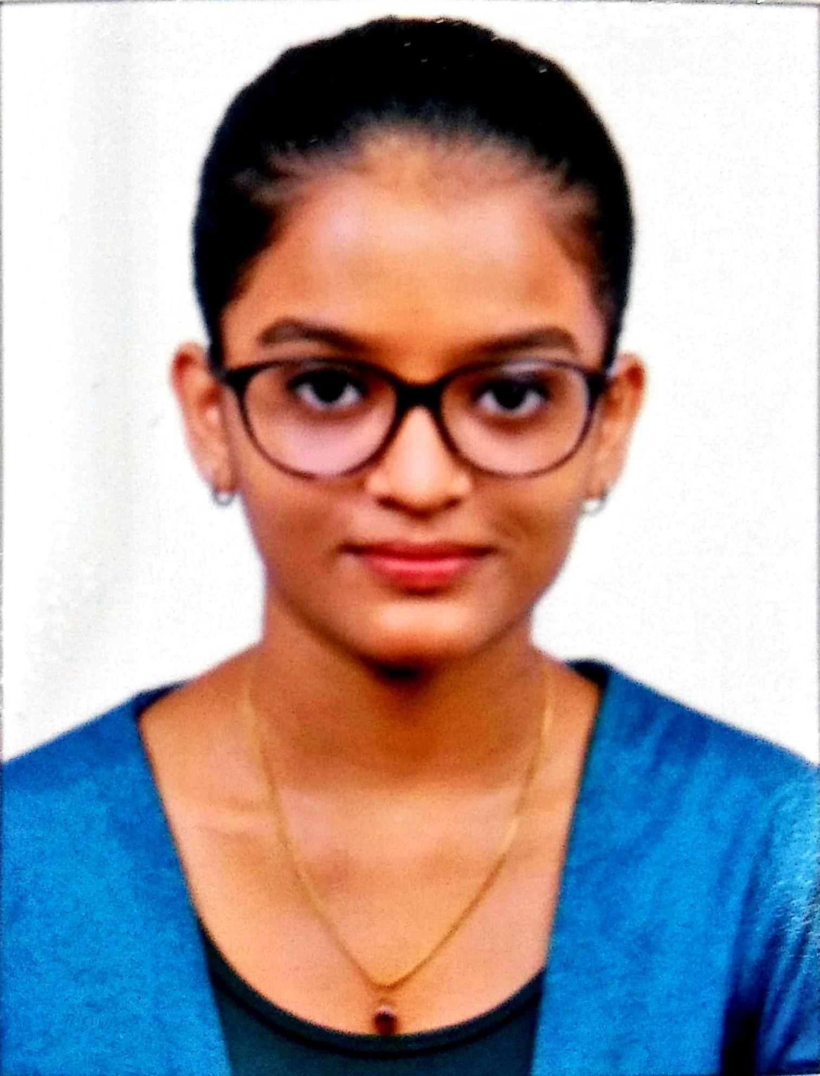
HRITIKA PRASHANT CHAVAN
C-1, Suyog C.H.S., Plot No. 96, Gorai 1, Borivali West,
Mumbai 400091.
☎ 8291202520 | 📧 hritikachavan24@gmail.com

OBJECTIVE
Seeking a great experience in all fields of your organization along with overall organization growth and an opportunity to be part of a dynamic environment.
ACADEMIC AND PROFESSIONAL QUALIFICATION

COURSE | SCHOOL/COLLEGE/INSTITUTE | YEAR OF PASSING | PERCENTAGE/  GRADE(GPA)
B.COM  (SEM V) | M.L. DAHANUKAR COLLEGE | 2020 | O (10)
INTERMEDIATE (NEW) | THE INSTITUTE OF CHARTERED ACCOUNTANTS OF INDIA | (PURSUING)
CPT | THE INSTITUTE OF CHARTERED ACCOUNTANTS OF INDIA | 2018
HSC | M.L. DAHANUKAR COLLEGE | 2018 | 74%
SSC | S.V.I.S. (GORAI) | 2016 | 82%

COMPUTER SKILLS
- MS OFFICE
- TALLY
- CAAT
OTHER SKILLS
- CAN WORK INDEPENDENTLY AS WELL AS ALONG WITH TEAM
- GOOD LISTENING SKILLS
- TIME MANAGEMENT

CERTIFICATE
- ICITSS – ORIENTATION COURSE(OC) & INFORMATION TECHNOLOGY(IT) BY THE INSTITUTE OF CHARTERED ACCOUNTANTS OF INDIA (ICAI)

PERSONAL DETAILS

FATHER’S NAME | :- Prashant Chavan
MOTHER’S NAME | :- Pallavi Chavan
DATE OF BIRTH | :- 12th April, 2000
HOBBIES | :- 🎂 Baking Cakes  📖 Reading Novels (GENRE: FICTION)
LANGUAGE PROFICIENCY | :- English ◾◾◾◾  Marathi ◾◾◾◾  Hindi ◾◾◾◾  French ◾◾◾

PLACE : MUMBAI (HRITIKA CHAVAN)

