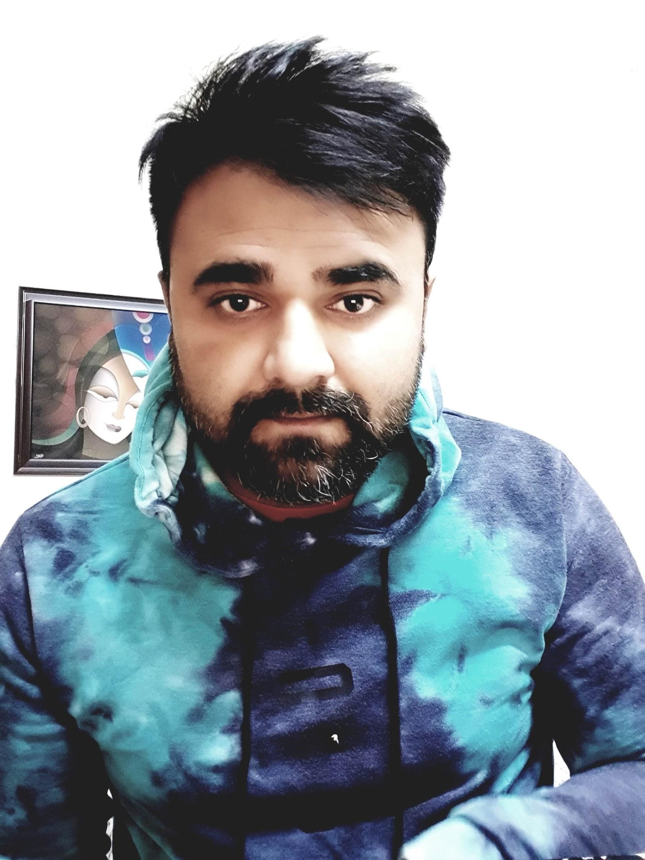**Resume**

**Mob.** +9711287524**| Email**: [sinha.pratik47@gmail.com](mailto:sinha.pratik47@gmail.com) **Gurugram, IN *“****Focused and skilled towards a career to be a member striving for company’s growth”*

***Academic Qualification***

**B-Tech in CSIT** from **St. Mary’s College of Engineering and Technology**, Hyderabad (**JNTU**) in 2013

## Industry Experience

**Overall, 4 Yrs of Experience –**

* **Accenture-Dec-2018 to Mar-2022.**
* Worked on **SRT Tool** and **AWS Tool** as an **Analyst** in **Business Risk Investigation** and **Payments & Compliance.**

- Handling Transactions Search Operations, Transactions Monitoring, **AML** (Anti Money Laundering), **SAR** (Suspicious Activity Report), **PMLA** (Prevention of Money Laundering Act, 2002), **FATF** (Financial Action Task Force) And **FATCA** (Foreign Accounts Tax Compliance Act), OFAC, ✓ Expertise in **AML/CFT** (Anti-Money Laundering and Counter-Terrorist Financing) and **KYC User Profile Investigation**. **AML/KYC/Compliance**, **Sanctions**, **PEP** (Politically exposed person).

-Worked as a **QA-** Managing Data, Auditing cases for tier 1, finding out errors followed by feedback and RCA, and finally documenting

reports to leads on a daily/weekly basis based on requirements and Client Interactions.

* **Machine Learning/AI- Front-End Support (AWS Tool)**

-Deep Investigations as Products Classifications and Data Point Attributes Identifications and Extractions.

Products Investigation, Products Comparison, Products Comparison and External Search Brand Validation.

-Good experience in test design

-Understanding of different testing types: regression, integration, scale/performance, black-box, white-box testing

Experience in analyzing results of test execution and compiling test reports

Create and maintain test cases and test data using Quality Center/Team Foundation Server and other tools.

* **AK Global Info Solutions LLP**: - **Mar 2018-Nov 2018** (Microsoft 365 cloud support + Norton 360- Technical Support L1 Desk)- Worked as a **Technical Support Consultant**- Handling Server Support on Remote Desktop. Talking customers through a series of actions to resolve a problem. Following up with clients to ensure the problem is resolved. Replacing or repairing the necessary parts. Supporting the roll-out of new applications. Providing support in the form of procedural documentation. Managing multiple cases at one time. Testing and evaluating new technologies.

## Software Exposure

* Programming Language:  Java, Python Programming.
* DATABASE: SQL Server 2000/2005, Access
* Operating System: Windows Server 2003, Windows Server 2008/R2, Windows 7/XP
* Office Automation MS Word, MS Excel, PowerPoint.
* Tools AWS, SRT and LMI GTA, TeamViewer

## Personal strengths

* Great Customer Service & Communication skills.
* Adaptable to new things and Quick Learner. Effective Organizational & Time Management Skills.
* Good at Decision Making
* Self-Motivated and Hardworking.

## Areas of Expertise

* Operational Tasks Work.
* Quality Assurance.
* Team Performance & Management.
* Data Analysis and Reporting.
* Excellent Office Automation Skills in Microsoft Word, Excel and PowerPoint.
* Hands on experience on remote desktop tools
* Experience working in global, complex, customer-oriented IT environment
* Experience implementing a variety of integration technologies
* Extensive experience with Networking, Software Development and Remote Desktop and Computer Apps Solutions.
* Experience implementing a variety of integration technologies

## Key Skills

* Knowledge of Front-End Technology like HTML, CSS and JavaScript.
* Basics of Cloud computing.
* Knowledge of RDBMS tools like SQL and MY SQL
* Practice on Data Visualization and Microsoft Power BI Desktop and Services
* RESTful API’S, MicroServices, AWS Cloud Services (S3, EC2, SQS, RDS, Others), GCP

***Hobbies***

* Travelling
* Cooking.
* Listening to Music.

***Personal Details***

|  |  |
| --- | --- |
| Name: | Pratik Kumar Sinha |
| Father’s Name: | Shashi Bhushan Prasad Sinha |
| Date of Birth: | 1st February 1992 |
| Nationality: | Indian |

     Languages: English, Hindi

     Address: Ward 12, Near Redia House, Sasaram, Bihar, 821115

Thank You