

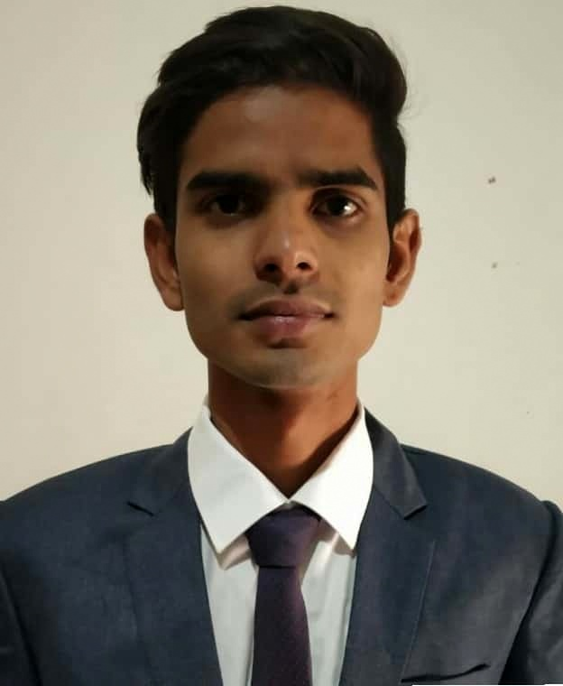

**Bhavesh Mishra**

**Specialization: Finance**

**Date Of Birth: 20 October 1995**

**Education Summary**

|  |  |  |  |  |  |
| --- | --- | --- | --- | --- | --- |
| **Academic Level** | **Stream** | **Name of Institution & Board/ University** | **Year of Completion** | **Percentage**  **(**%**)** | **Division/CGPA** |
| **Post-Graduation** | MBA  (Finance) | Savitribai Phule Pune University, Pune,(Maharshtra) | 2020 | 68.5 | 1st |
| **Graduation** | B.Com | Veer Narmad South Gujarat University,Surat(Gujarat) | 2016 | 59.0 | 2nd |
| **Higher Secondary** | HSC  Commerce | Sh. Sardar Patel Higher Sec. School,Surat(Gujarat) Gujarat Board | 2013 | 47.0 | 2nd |
| **Senior Secondary** | SSC | Sh. Sardar Patel Higher Sec. School,Surat(Gujarat) Gujarat Board | 2011 | 64.8 | 1st |

**Summer Internship Project**

**Organization Name: DCB BANK, Pune**

**Duration : 2 Months (16/05/2019 to 16/07/2019)**

**Project Title : A Report on Study of Credit Appraisal Process**

**Academic Projects**

|  |  |
| --- | --- |
| **Objectives :** | 1.To understanding the procedure and process used by DCB bank to assess the credit worthiness of borrower.  2.To study parameters of credit risk assessment of client. |
| **Methodology:** | 1.Primary Data : SME Credit cell department of DCB Bank LTD.  2.Secondary Data : Books and DCB bank websites, etc. |
| **Learning:** | 1.Process of SME lending at DCB Bank.  2.Parameters to assess the business.  3.CIBIL Report Analysis and Financials. |

**Academic Projects**

Pre Induction Project : Is Foreign Direct Investment (FDI) in retail sector good for India

Any other Project : Yash Raj films vs Eros International (Marketing Strategies in India)

**Trainings/Certifications/Workshops Attended/Industrial Visits**

* MDP-IIM Indore
* Digital Marketing Certificate
* Ms-excel
* Aptitude training
* Industrial Visits

Visit to IIM-Indore, JK Tyre -Indore, Cotton King Plant -Baramati, Nandan Dairy -Baramati, Greaves Cotton –Pune

**Working Experience**

* Worked in HDFC sales Private Limited as operation executive for 8 months.
* Worked in Teamlease Services Limited as MIS executive for 7 months.

**Co-Curricular,Extra Curricular Exposure and Achievements**

* Participated as Stand up comedian and was a finalist, organised by Radio Mirchi.
* Participated in various Game at school and college level.
* Certificate of Appreciation for 2nd position in the event Rogue Traders Dhruv 2019
* Participated in Credit Research Challenge,NISM
* Participated in Express Trading and Investing 1 Day Workshop

**Personal Details**

**Hobbies :** Playing Cricket, Chess and Football, Traveling, Cooking, Reading

**Languages known :** English, Hindi and Gujarati