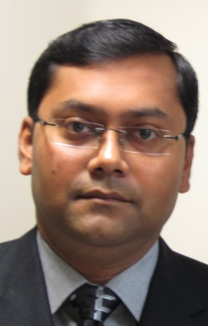 Indranil Saha
Mobile: +91-9748982279
E-Mail: indksm1977@gmail.com

SENIOR LEVEL ASSIGNMENTS
~Service Operations ~Client Relationship Management
Offering rich business acumen & achievements in the Office Automation Sector across a diverse range of functions
In quest of an exciting career which would help in contributing towards the growth of an organization through acumen perfected by keen observation and meticulous analysis of real life situations- be it marketplace, corporate world, social gatherings or knowledge gained through books and academic sources

Profile Summary

- Over 19 years of experience in Service Operations, Client Relationship Management and Team Management
- Expert in managing service operations while ensuring top line profitability of the organization
- Skilled in managing business operations with focus on top-line performance through after & pre sales strategies, business alliances & client servicing
- Competent in defining effective business solutions as per client's needs with an aim to improve customer contentment & loyalty for repeat & referral business
- Highly successful in driving revenue & profit gains and improving organisational perfomance .
- Adopt in initiating & developing relationships with key decision-makers in target organizations for business development and revenue generation
- Demonstrated success in end-to-end project launch while ensuring effective management of various resources to meet project specifications
- An enterprising leader with excellent client servicing, interpersonal and problem solving skills

PROFICIENCY MATRIX

~ Service Operations
~Business Development
~Product Management
~Client Relationship Management
~Team Management
~Brand Promotion
~MIS Reporting
~Quality & Audit
~Channel & Vendor Management

Leadership: Advises the management on business strategies promotes organization among customers & drives mission through employees & supports motivation of employees
Decision Making: Formulates policies and planning recommendations to the management, decides or guides courses of action in operations by staff / employees
Personal Credibility: Uses personal credibility to influence outcomes beyond own business & functional area

Core Competencies
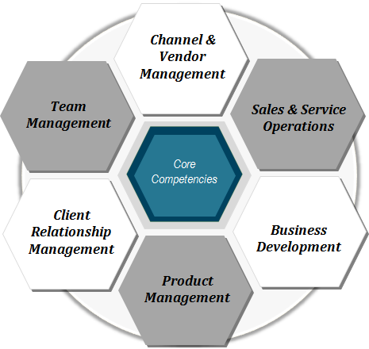
Service Operations
- Administering service operations, implementing plans & policies for organization and ensuring accomplishment of business goals
- Handling service coordination of the different areas and after sales service activities

Client Servicing
- Building and maintaining healthy business relations with key clients & channel partners and ensuring maximum customer satisfaction
- Enhancing customer satisfaction matrices through suitable product offerings and resolving customer complaints

Business Development
- Implementing business development plans for achievement of revenue and profitability targets
- Identifying and networking with prospective clients, generating business from the existing accounts and achieving increased sales

Organisational Experience
Panasonic  Canon | 2017 July to till date as Regional service Manager – EAST (SSD operations).  - Handling service operations of entire EAST through ASCs.  - Maintaining installation & Repair TAT well within target.  - Dealing in Cameras, commercial panels, printers, Fax, scanners, projectors, EPABX, telephones, cordless phones, Toughbook , CCTV – servicing of these products.  - Achieving target of EWC as per company’s requirement.  - Support sales team for business development.  - Appointment of ASCs for better coverage and performance spreaded over entire EAST.  2010- 2017 Canon India Pvt Ltd Kolkata, West Bengal as Customer Support Manager  * Achieve revenue target and service performance parameters by supporting direct team to improve revenue and coordinating the availability of spares and consumables at branch location, also looking after Dealer business for entire West Bengal & Sikkim. Handling the entire EAST region now as Ad hoc role.  * Assist the dealers as well to recruit Service Engineers as per Canon standard.  * Monitoring service activity (Installation, Call Monitoring, response time, down time, CQM, ECF & contract conversion) of Engineers.  * Assessment of Engineer Skill and initiate corrective action on the Gap observed.  * Ensure Service report & installation report submitted by Engineers is updated into system (CMP).  * To help dealer for execution of service contract agreement with customers and improve contract penetration at dealer location & also execute service contract agreement of machines directly handled by Canon Engineer. Looking after Dealers of West Bengal & Sikkim for service operation.  * Generate system report on service parameters and analyse for corrective action.  * Identify and resolve customer issues and take preventive actions.  * To evaluate dealers periodically and prepare development plan for improvement of identified areas.  * Support Sales Team for Business development.
 | 2008–2010 HCL Infosystems Ltd Kolkata, West Bengal  Territory Manager  * Provide Technical support to the engineers for various ranges of Digital Multifunctional Products and install new machines.  * Get customer into maintenance agreement, sales and supply of consumables item and ensure that payment is collected within the credit policy of the company by the payment collectors.  Looking after the entire service operation of Kolkata Branch with full confidence and pride and helped in generating more business.
 | 2000-2008 Ricoh India Pvt Ltd(erstwhile Gestetner India Pvt Ltd upto 2005) Kolkata, West Bengal.  Sr. Customer Support Engineer  * Provide Technical support to various ranges of Digital Multifunctional Products and install new machines.  * Provide training to customer for better operation of machines and do customer survey to upgrade customer data.  * Provide technical support to other Engineer and provide catch-up training to new Engineers.
Education | 1996–2000 Kalyani University(AICTE Approved , Presently WBCTE) Kolkata.  B.Tech In Electronics & Telecommunication in First Class.
Date of Birth | November 8th, 1977
Father’s Name | Dr. Bikas Chandra Saha
Address for Communication | 3, Kalibari Lane, Flat-3. Jadavpur. Kolkata-700032.
Interests | Listening to music, gaining knowledge through net surfing.  Current CTC: 19.74 lakhs  Expected CTC: Negotiable
Signature:
Place : Kolkata

