**RESUME**

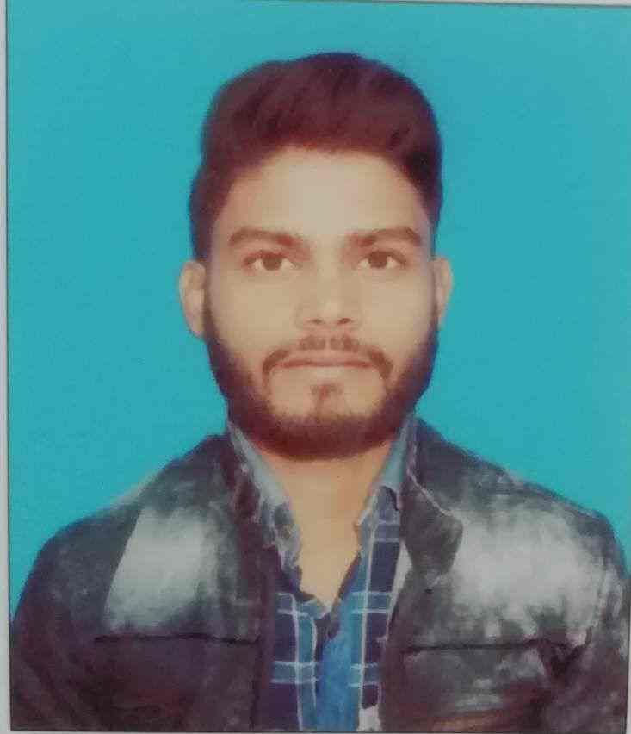

RAGHAV ROSHAN

**Personal Information**

Father’s Name – RAMDHANI PASWAN

Address- CHAKLA NIRMALI, WARD NO-07, SUPAUL

BIHAR

PIN- 852131

Mobile- 7635081661

DOB- 04th February 1997

Sex- Male

Marital Status- Unmarried

Nationality- Indian

Category- SC

Language Known- Hindi, English

# Hobbies

Reading, Writing poems

# Objective

To enhance my skills, capabilities and knowledge in an organization which recognizes the value of hard work and trusts me with responsibilities and challenges.

# Experience

Worked as a Biometric Operator

Sify Technologies, Bhagalpur

2017- 2018 5 Month Experience

# Education

|  |  |  |  |
| --- | --- | --- | --- |
| **Examination Passed** | **Board/University** | **Year of Passing** | **% of Marks** |
| X | Bihar School Of Examination Board (BSEB) | 2013 | 48.6% |
| XII | Bihar School Of Examination Board (BSEB) | 2015 | 56.2% |
| GRADUATION | Tilka Manjhi Bhagalpur University (TMBU)  SUBJECT -Bachelors Of Computer Application(BCA) | 2018 | 62.19% |
| POST-GRADUATION | Tilka Manjhi Bhagalpur University (TMBU)  SUBJECT- Masters In Computer Application (MCA) | 2019 to Present | 1st sem – 72.2% |

# general Skills

* Basic command in C , C++ and Java
* HTML + CSS
* Advance knowledge of MS Office- MS Word , MS Excel , MS PowerPoint etc.

# SOFT SKILLS

* Problem solving skills
* Quick learner and hardworking
* Dedication for committed work
* Elegant team player.
* Ability to cope up with different situations

# Achievements & awards

Certificate received in Python from Kshitij IIT Kharagpur -2018

Venue- T.N.B College, Bhagalpur(Bihar)