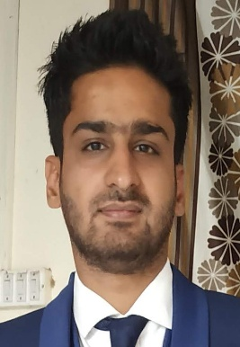**CURRICULUM VITAE**

**ZUHAIB AHMAD AKHOON**

**Mobile: –** **+917006971258**

**E-Mail:-**[**ahmadzohaibb@gmail.com**](mailto:ahmadzohaibb@gmail.com)

**Date of Birth: -20thjune 1995**

**Summary :-**

I am an enthusiastic fresher with highly motivated and leadership skills having bachelors of engineering degree in Information Technology. Eager to learn new technologies and methodologies. Alwayswilling to innovate the new things which can improve the existing technology.

**Experiece:**

2019-20: Trainee at AIG business solutions

**Skills:**

* Knowledge of Routers and Switches
* Knowledge of routing protocols such as RIPV1/V2,EIGRP,OSPF
* Knowledge of vlan,STP,DHCP,syslog,TELNET,SSH
* Knowledge of IPV4 ,IPV6,Subnetting
* Knowledge ofc,c++,java, html ,sql ,php, java script
* Knowledge about database
* Software skills CODEBLOCK and NETBEANS,TURBO C++.

**Academic Qualification:**

|  |  |  |  |
| --- | --- | --- | --- |
| Course | Institution | University/Board | Percentage |
| B.E. | Mahant Bachittar Singh College of Engineering & technology, Jammu | Jammu University | 72% |
| 12th | Govt. Boys Higher Secondary, Kashmir | JKBOSE | 63% |
| 10th | Shaheen Public high School, Kashmir | JKBOSE | 69% |

Industrial Training:

* Six weeks training in Java from National Institute of Electronics & Information Technology.
* Trainning in networking(ccna R&S)

**Major Project**

* Health Monitoring System
* **Language used :-** HTML, Java Script ,PHP,CSS
* **Database :-** MYSQL

The basic design of health monitoring system on a web application is that the application sits on a web server, and all users will access it via web browser over the internet/HTTP. This is more user convenient as people from worldwide can fix their appointment for consultant to their favourite doctors. Rescheduling/Cancelling of appointment is also available as in case of any urgency.

**Relevant Courses**

* Digital communication, Analog Communication, Interactive Computer Graphics, Analog Electronic, Data structure, computer Organisation, Microprocessor.

**Strengths**

* Good Planning Skills.
* Good learner.
* Can work effectively in a team as well as independently.
* Patience & confidence.
* Positive attitude.

Achievement&Extra Activities

* First Prize in Dazzle Debugging event organized by Techo fest in our college.
* First prize in event Pictionary organised in our college.
* Member of Organising Committee (Event Organiser) in techno cultural fest held in our college

**Personal Information:**

**Father's Name :- Mehraj-ud-din Akhoon**

**Mother’s Name**:- Fehmeeda  
**Marital status: -** Single  
**Nationality :-** Indian

**Sex: -** Male

**Languages Known: -** English,Arabic,Urdu, Kashmiri

**Permanent Address: -**Nowpora sekidafar srinagar,Jammu and Kashmir

**Declaration:**

I hereby declare that all the information provided here is correct to the best of my knowledge and belief and I bear the responsibility for the correctness of the above mentioned particulars.

Date: Signature

Place: J&K Zuhaib Ahmad Akhoon