MOHAN KUMAR  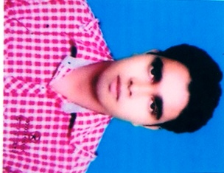  CONTACT  Address:  304/16, Jatwada mohala,  Biswa -7, Bahadurgarh,  Haryana  Phone:  9034001051, 8708179667  Email:  mohankumarpandit20@gmail.com  LANGUAGES  Hindi  English |  | OBJECTIVE  - To obtain a challenging position is the cutting edge of technologies where experience, education, training and a strong professional growth can be fully and productively utilized. Professionalism and satisfaction are strong factors in my carries.  WORK EXPERIENCE  Working in S.V. International School Garhi, Sampla (Rohtak) from 08 May 2013.As a Computer Teacher, (theory with practical), Hardware and Networking Work, Manage all type of function, Computer Operator, and Administration, Computer Lab attendant.  EDUCATION  - MCA from Swami Vivekanand Subharti University.  - Graduation from Patna University DDE.  - 12th H.B.S.E. Board Haryana in 2008  - 10th H.B.S.E. Board Haryana in 2006  ADDITIONAL SKILLS  - Diploma in Advance Accountancy (DAA)  - ZCE (Zed Certified Engineer)  - Field Technician-Computing and Peripherals from N.S.D.C  - English Typing Speed 45 WPM.  - Hindi Typing Speed 30 WPM  STRENGTH  - Eagerness to explore and learn new technologies and concept.  - Hard work, Team Leading, Management  NATURE  - Honest & Hard working  INTEREST AND ACTIVITIES  - Playing cricket, watching historical channel.  - Traveling, making friend & learning books.  PERSONAL INFORMATION  - Name Mohan Kumar  - Date of birth 10th Dec., 1990  - Father name Mr. Vinod Kumar  - Sex Male  - Marital status Married  - Religion Hindu  - Nationality Indian  DECLARATION  I hereby declare that the above furnished details are true to the best of my knowledge and belief.  Date:  Place: Mohan Kumar

