1. PERSONAL DETAILS:

• NAME - KASHISH RUPANI

• FATHER’S NAME – KAMAL RUPANI

• MOTHER’S NAME – RITIKA RUPANI

1. EDUCATIONAL QUALIFICATIONS:

• CLASS 12TH PASS FROM CENTRAL BOARD OF SECONDARY EDUCATION

• STREAM - ARTS

• SCHOOL – SUNBEAM SCHOOL LAHARTARA

• SCHOOL ADDRESS – NEAR LAHARTARA OVERBRIDGE, LAHARTARA BOULIA, VARANASI, UTTAR PRADESH, 221002

• GRADUATION YEAR – 2021

1. CURRENT EDUCATIONAL LEVEL:

COLLEGE - MITHIBAI COLLEGE OF ARTS, CHAUHAN INSTITUTE OF SCIENCE AND AMRUTBEN JIVANLAL COLLEGE OF COMMERCE AND ECONOMICS,

UNIVERSITY OF MUMBAI

COURSE – FIRST YEAR BACHELOR OF ARTS (FYBA)

1. CREDENTIALS:

First prize in impromptu Writing Competition, hosted by Seth Anandram Jaipuria School, Kanpur (2020)

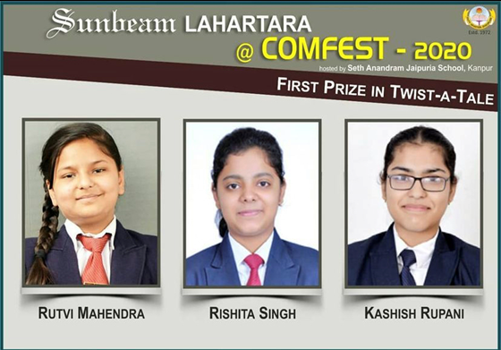

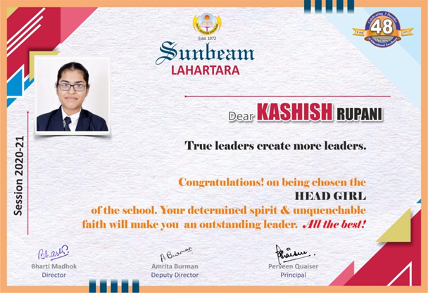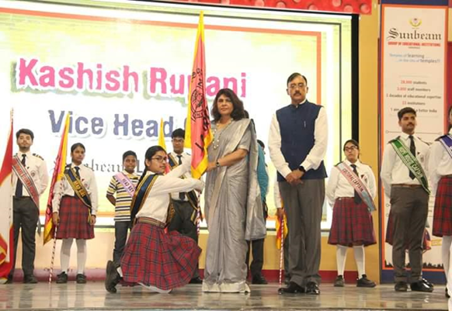 Vice Head Girl and Head Girl of the school in 11th and 12th grade respectively.

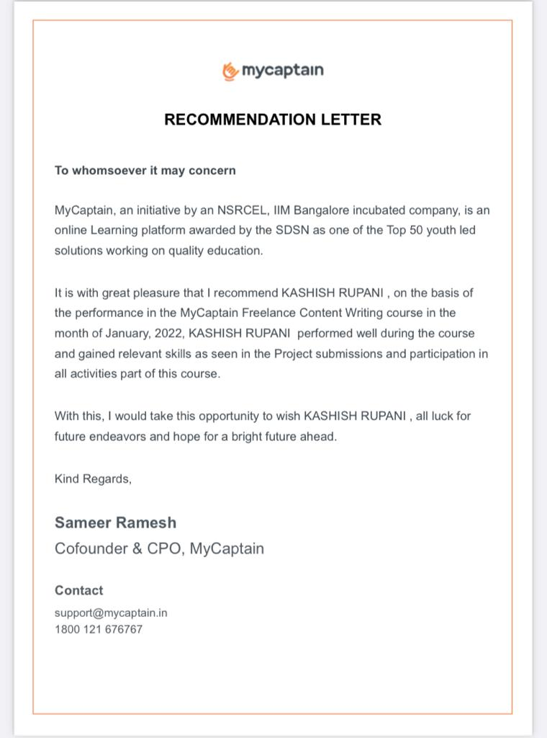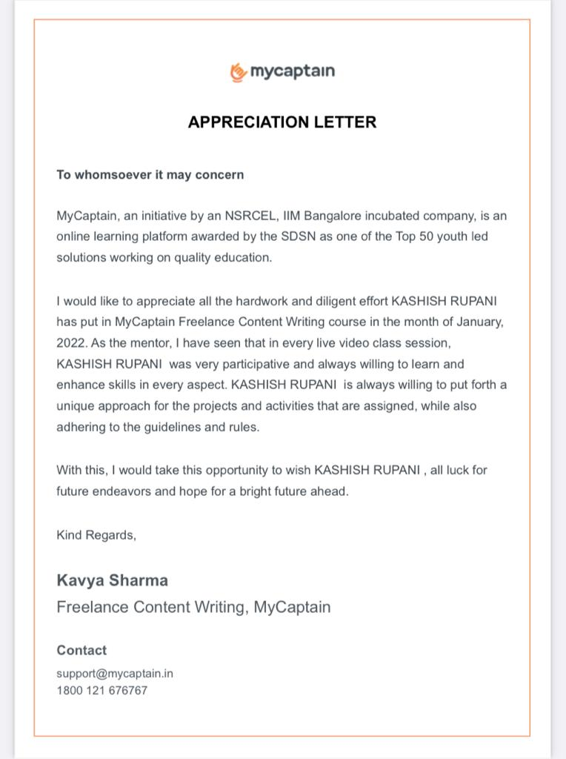Got an LOR and LOA from My Captain, an initiative by NSRCEL, IIM Bangalore (Freelance Content Writing Course)

Currently working with a mental health organization called Healing Anonymously as a Content Writer Volunteer.

1. My write-ups and articles:

Blog:

<https://drive.google.com/file/d/10-gJXkH3UC7eUTYof-ngsukL0GcHwjxZ/view?usp=drivesdk>

Blog:

<https://drive.google.com/file/d/1a_KwNM9-HkU3zvhsMpufDC7FGHiNtuVj/view?usp=drivesdk>

Article Review:

<https://drive.google.com/file/d/1lyTTXpWj6gp1LwtB1sS2tbUrXXrd_iCp/view?usp=drivesdk>

Article:

<https://drive.google.com/file/d/1tUyGfP42Jkt_3H-_abYTbOaCTfHAyryR/view?usp=drivesdk>

Case Study Article (Most Recent):

<file:///C:/Users/HP/Downloads/PRIVACY%20IN%20THE%20CONTEMPORARY%20SCENARIO-%20A%20Short%20Case%20Study%20of%20New%20Zealand.pdf>

1. General Qualities and Domain of Excellence:

My hobbies include Reading a lot, as well as Writing on subjects I am passionate about. Apart from that, I like Travelling as well.

When it comes to Writing, my area of expertise includes writing about topics of Psychology, Sociology, Human Resources, Politics, and Criminal Research.

I belonged to a Psychology background in 11th and 12th grade, and I was also a part of the Quiz and Debate team. So, I am naturally inquisitive about new topics, and writing about them.

I was a part of my School’s Editorial Team, and have written various articles for my school newsletter as well. I have also won many writing competitions.

1. Why I want to do Content Writing?

I believe that writing is one of the best forms of expression and awareness. I am a believer of ‘Pen is mightier than Sword.’ Since I grasped the true meaning of how to write, the prospects of doing it professionally always fascinated me. I like both Social and Commercial Writing.

I feel it is a terrific way of improving your skills, delivering them for good, and learning and growing. The field of Content Writing is still in its developing phase, which is why I believe that there is a lot of untapped scope in it. I would like to be a part of this developing and amazing industry.

***Thank You!!***